Interactive innovation is a key factor influencing the sustainability of value chains in the wine sector
José Muñoz-Rojasª, María Riveraª, José Ferragolo da Veigaª, João Luis Barroso^{b}, Teresa Pinto-Correiaª, Åke Thidell^{c}

ª MED-Mediterranean Institute for Agriculture, Environment and Development. Universidade de Évora. Campus de Mitra. Valverde, Évora. 7006-554. Portugal. jmrojas@uevora.pt; mrmendez@uevora.pt; jffveiga@uevora.pt; mtpc@uevora.pt
^{b} Programa de Sustentabilidade dos Vinhos do Alentejo. Comissão Vitivinícola Regional Alentejana (CVRA), Horta das Figueiras. Rua Fernanda Seno nº 12 7005-485 Évora, joao.barroso@vinhosdoalentejo.pt
^{c}University of Lund. International Institute for Industrial Environmental Economics (IIIEE), Lund University P.O, Box 196, 221 00 Lund, Swedenaake.thidell@iiiee.lu.se

Abstract

More innovative management strategies in the wine sector are required to move towards enhanced sustainability standards that are increasingly in demand. Such strategies need to encompass the whole value-chains if they aspire to become effective in their territorial context, beyond the farm level. Innovation is hereby unrestricted to technological aspects, and also encompasses social, environmental, institutional, territorial and organizational elements, that are equally relevant.
Interactive innovation, whereby diverse actors and networks mutually interact across different components and stages of the food value-chain, is currently advocated by EU´s rural development strategies to enhance the sustainability of the farming sector. Under such interactive innovation paradigm, sustainability needs to be considered as relational. Using the Wine Sustainability Program of Alentejo (Portugal) as case study, we assessed how interactive innovation is effectively enacted and how it can enhance the sustainability of wine value chains across scales ranging from the farm to the region.
To do this we examined data from quantitative-bio/physical and qualitative-social assessments to elicit indicators and narratives useful to identify current gaps and future improvements. Results and lessons learnt indicate to relevant aspects so far largely under-considered such as the key role of individual champions in leading by example, of open-ended stakeholder networks for knowledge and action co-construction, the sheer importance of shared values, and lastly the relevance of horizontal cooperation (amongst farmers) and vertical coordination (along the value chain) for sustainability purposes. Naturally, this does not provide a one-size-fits-all pathway towards enhanced sustainability standards in the wine sector, but it shows the potential role to be played by interactive innovation as a key factor for enhancing such standards in ways that have been, so far, largely marginalized.

Key words – Interactive Innovation; Agricultural Value Chains; Alentejo (Portugal); (Relational) Sustainability; Institutional Networks; Wine.
Table of Contents
1. Introduction 2
1.1. Interactive innovation and food value chain sustainability. 2
1.2. Interactive innovations influencing sustainability in the wine sector. 4
1.3. Wine value chains in Portugal and Alentejo 5
2. The Wine Sustainability Program of Alentejo (Portugal): Background 8
3. Assessing WASP’s sustainable interactive innovations: 9
3.1. Quantitative assessment: 9
3.2. Qualitative assessment 12
4. Results of WASP’s quantitative assessment 14
4.1. How numbers have evolved 14
5. Results of WASP’s qualitative assessment 15
5.1. Dynamic Leadership 15
5.2. Shared Values 16
5.3. Stakeholder engagement: Network evolution process over time 16
6. Final Reflections and conclusions 17
References 18

1. Introduction

1.1. Interactive innovation and food value chain sustainability.
The EU Commission (EC) has provided the following definition of innovation as part of their European Innovation Partnership for Agricultural productivity and Sustainability (EIP-AGRI): “Innovation is often described as a new idea that proves successful in practice. Innovation may be technological, but also non-technological, organizational or social. Innovation may be based on new but also on traditional practices in a new geographical or environmental context. The new idea can be a new product, practice, service, production process or a new way of organizing things, etc. Such a new idea turns into an innovation only if it is widely adopted and proves its usefulness in practice.” (COM, 2014). Innovation in farming systems thus implies that something new or significantly improved is in place, but also that such novelties are implemented through successful practices.

Common within the innovation literature is the distinction between two models of innovation (Knickel et al, 2009). Firstly, there are the ‘linear-type’ models of largely top-down and science-led innovation, focusing on technologies, driven mainly by economic competitiveness and measuring impact in terms of efficiency, effectiveness and productivity. On the other hand, one can find the systemic or ‘alternative’ approaches to innovation which is understood as a social and inherently complex process rather than a singularly technological one (Buller et al, 2019). Under the “alternative approaches” we can talk about interactive innovation, which implies adopting a discursive and interactive form of context-specific, multi-actor, multi-knowledge and end-user focused engagement that combines social practices with structures (Buller et al, 2019). This is an approach to innovation where diverse actors and networks mutually, constructively and intentionally interact across different components and stages of the value-chain and is currently advocated by EU´s rural development strategies to enhance the sustainability of the agricultural and food sectors. In such context, the European Evaluation Helpdesk (2017) identifies 3 (mutually overlapping and interlinked) requirements for achieving interactive innovation: development of new ideas, consolidation of the processes through which individuals engage with the knowledge innovation system, and enabling of a multitude of actors and related networks by the institutional and policy environments.
To achieve interactive innovation, it is necessary to create a space for joint learning and knowledge sharing through innovation networks which bring together different actors, with different (forms or sources of) knowledge (Ingram et al, 2015). Innovation networks can be formal or informal, territorial or sectoral, horizontally or vertically integrated. Moreover, it is now widely acknowledged that innovation networks are dynamic in nature (Klerkx et al, 2013). Their composition can change over time as priorities and access to resources of actors change and vary in shape and size and in the strength of their relationships between their members. Such networks may well include business clusters, multi-actor, territorial alliances, public-private partnerships and learning agreements (Neumeyer et al, 2012).
Overall, interactive innovation seems to call for a shift in the strategic mindset of producers, market agents and public actors operating along the value chain to move from a competitive approach towards a cooperative approach to joint strategy making (Ingram et al, 2015). This may prove as especially relevant in a sector, wine production, where fierce competition amongst regional wine trademarks in the globalized market-sphere seem to be at odds with the expectations for an agricultural produce that largely exceeds the condition of commodity, linking with territorial concepts such as terroir, and thus where distinctiveness and competitive advantages may become more apparent and efficient at an above-the-farm scale (Merli et al, 2018).

The aim of this chapter is to exemplify how these aspects are tackled in the real world through a successful case study of sustainable interactive innovation in the Alentejo region (Portugal). Using the Wine Sustainability Program of Alentejo (Portugal) as case study, we assessed how interactive innovation is effectively enacted via the WASP (PSVA in Portuguese) and how this has effectively contributed to enhancing the sustainability of wine value chains across scales ranging from the farm to the region. To do this, we use a mixed-method approach that combines qualitative and quantitative analysis, and social, economic and environmental indicators and metrics for sustainability. The novelty of such an approach comes from considering together objective (as obtained by applying objective metric obtained in the field and wine cellar) and rather subjective (perceived and contingent to the socio-cultural context on which they are produced) data to extract a joint a unique set of conclusions that provide with a unified overview of the social-ecological sustainability of the wine production system. This is something that remains so far largely untested, with most sustainability studies focusing either on achieving quality standards that can be quantitatively demonstrated, and rather independently applying a research-based approach to elicit subjective narratives and scenarios towards sustainability (Merli et al, 2018).
The structure of the chapter is as follows: Firstly we describe the rationale behind the analysis of interactive innovation as a key factor influencing sustainability goals and standards (section 1.2), we then describe the value chains and socio-economic and territorial relevance of the wine sector in Portugal and Alentejo (section 1.3). Section 2 is devoted to describing in detail the Wine Sustainability Program of Alentejo (WASP, or PSVA in Portuguese, in the original), including its trajectory, outreach, actor-network structure and subsequent stages. In section 3, we describe the quantitative (3.1) and qualitative (3.2) methods employed and results obtained in the analysis of the WASP, that are then discussed in section 4, which finalizes by presenting the key conclusions reached and lessons learnt for the future.

1.2. Interactive innovations influencing sustainability in the wine sector.
The key role that is played by sustainability in the on-going transformations of the wine industry and related value-chains is well evidenced by the significant attention being paid to this issue across the academia, public and private institutions, farm producers and sectoral associations (Santini et al, 2015). Nevertheless, what remains highly arguable in agriculture, is how sustainability should be enacted, measured and monitored. Achieving farm-level sustainability is a complex venture. As stated by Ohmart (2008): “sustainability involves everything you do on the farm, including economics, environmental impacts of every single agricultural or forestry operation and all aspects of human resources, including not only you and your family but your employees and the surrounding community”.
In response to this, a mix-methods approach should be advocated for assessing sustainability which combines qualitative and quantitative, modelling and participatory, approaches and techniques. As examined by Santini et al (2015) a relatively ample set of scientific literature exists addressing the sustainability of the wine sector via indicators that specifically apply either qualitative, quantitative or mixed methods of research, addressing topics of interest to innovation, such as strategies, entrepreneurial and consumer behavior, supply chain management and certification. In addition, the same authors identified wine sustainability aspects that have already been addressed in the scientific literature through indicators, including environmental sustainability, organic production models, eco-labelling, greener industrial processes, environmental consumer behavior, sustainable business strategies and farming-ecology connections. All of these are aspects that can be linked to one, or multiple, forms of innovation, and that have a strong interactive component.
One interesting example in the use of indicators for measuring sustainability was adopted in Australia (Santiago-Brown et al, 2015), that although was grounded on knowledge co-construction, was somehow restricted to a quantitative and largely bio-physical perspective, thus leaving behind key relevant qualitative and social aspects of sustainability that are the core of the definition of interactive forms of innovation. Drawing on all of this previous work, Merli et al (2018) synthesized the set of existing experiences and initiatives in the wine sector across places and farming systems as diverse as those in Italy, France, Austria, Germany, Spain, California, New Zealand, South Africa and Chile. The ultimate aim of these authors was developing an international indicator framework, largely drawing on concepts such as Life-Cycle-Assesment, that largely relies on technological innovation principles. Additionally, these same authors argued that knowledge co-construction and stakeholder coordination are now inarguably key issues to secure the efficiency and operationality of sustainability assessments in the wine sector, a condition that we hereby advocate can be best accomplished if interactive innovation approaches are adopted. Another key challenge that underpins all Wine Sustainability Programs worldwide, as identified by Merli et al (2018) is related to the territorial heterogeneities of the wine sector across the conditions, socio-cultural, economic and ecological, that are contingent to each of the diverse producing regions. Such heterogeneity demands that both sustainability and related innovation approaches are tackled in ways that balance the need to safeguard the regionally specific social-ecological characteristics of each wine-producing region, traditionally termed as the “terroir” (for an example of this in Portugal, see Martins et al, 2019), and the need to avoid using sustainability standards to justify undesirable the green-washing marketing approaches that are becoming increasingly extended in some sub-sectors of agriculture, and that are directly contrary to the principles of agroecology (Francis et al, 2003). Such a regionally targeted sustainability approach to innovation is effectively encompassed in the Wine Sustainability Program of Alentejo (Portugal), which will be the focus of this study.

1.3. Wine value chains in Portugal and Alentejo
According to the Portuguese Institute of Vineyards and Wine, between 2000 and 2018, Portugal shifted between a maximum wine production of 7.05 million Hl in 2015 and a minimum of 6.06 million Hl in 2018 (IVV, 2019). In Alentejo, over the same period the production of wine has also been fluctuant between different years, with 98,3 million l produced in 2018, a decrease of 8,3 million l (-8%) in relation to year 2018 (CVRA, 2020). According to that same source, the proportion of vineyards that are located in Alentejo has only slightly increased over the past 2 decades although this is the region where more new plantation rights have been granted in Portugal, with 35% of National ones, whilst the removal permission grants in the region over the past 10 years have been granted for 117,25 hectares, less than a 3 % of those at the National level (IVV, 2019). In total, in the Alentejo, 22.883 hectares of vineyards are now found, a number of 921,7 ha (+4,2%), with respect to year 2018 (CVRA, 2020).

The overall number of regionally certified (GPI/PDO) registered vineyard farmers in Alentejo in year 2019 was of 1534, and the number of wine producers of 124 (IVV, 2019). Overall, and considering both certified and non-certified wine producers, the mean size of vineyard farms in Alentejo has moved up from 6,02 Hectares in 2000 to 7.56 Hectares in 2018, being by far the largest farms in the country (across all other Portuguese regions, the average farm size generally around, or in cases even smaller to 1 Hectare) (IVV, 2019).

Wine consumption has steadily increased worldwide, passing from 226 million Hl of wine in 2000 to 246 million Hl in 2018 (IVV, 2019). The monetary values for both the worldwide exports and imports of wine have also steadily increased over the same period, a clear indicator that wine markets are becoming increasingly globalized. Despite this, no common trends over the past 20 years are found between yearly wine production rates in Portugal and worldwide, indicating a certain independence of the Portuguese wine sector from global trends in terms of production (IVV, 2019). In this period, the combined production in the 3 main wine producing countries worldwide, Italy, France and Spain, has declined from 4.12 M Hl in 2000 to 3.32 M Hl in 2018. This has been largely compensated by the rise in production in other EU countries, including Portugal. This is despite the fact that the land occupied by vineyards have declined in Portugal from 273 K Hectares in 1998 to 190 K Hectares in 2018 (IVV, 2019), although as we previously mentioned this trend has been largely heterogeneous across the different regions, with the Alentejo occupying the lead position in growth rates.

Regarding sales, in the Portuguese case, approximately 30% of the wine in the National market is directly channeled towards retail use in local bars and restaurants, with the remaining 70 % entering the national and international distribution chains. Nonetheless, profits from direct sales to bars and restaurants are 45% of the total (IVV, 2019). Prices in the National markets in 2018 were almost threefold for direct local sales to restaurants and bars (6.59 Euros /l) than for retail distribution (2.40 Euros/l). Certified wine (DOP, Organic) represented 64% of National sales in 2018 in Portugal, with prices 2.4 times higher (5.40 Euros/l vs 2.36 Euros/l for non-certified wine).

Regarding production costs, in Alentejo these were of 0.41 Euros /kg in 2019, compared to the mean national value of 0.40 Euros/Kg. Grape prices are higher in Alentejo (1.14 Euros/Kg) than Nationally (0.75 Euros/Kg). The productivity in the production of grapes for wine in Alentejo is of 6458 KIg/hectare, a value that is very close to the mean Portuguese value of 6584 Kg/Hectare (IVV, 2019). This gives an idea that little differences are currently detected in terms of key prices between Alentejo, and Portugal in general.

From an overall perspective, Portugal has moved from exporting wine for a value of 519 M Euros in 2000 to 804 M Euros in 2019. In contrast, imports of wine have remained quite stable (109 M Euros in 2000, and 157 M Euros in 2019), thus shifting positively its national trade balance (IVV, 2019). The main target countries for exports of Portuguese wines now include France (14.4 %), the US (10.1%) and the UK (9.4 %), the fist 2 of which are direct producing competitors, indicating the enhanced competitiveness of the sector. The hierarchy of countries to where wines from Alentejo are now exports its wines remains the same (CVRA, 2020)

Once we combine all of these data together, one gets the overall impression that the wine sector in Alentejo is rapidly gaining economic strength, when compared to the Portuguese and EU trends. Although challenges related to productivity and market competitiveness and differentiation persist in the wine sector of Alentejo, they are nonetheless being gradually tackled.

It is important to indicate, at this point, to the legal requirement that is in place for vine farmers and wine producers to get inscribed in the official registry, that is regulated through specific regulations at the National level, including: Decreto-Lei n.º 178/99, and Portaria n.º 8/2000. This secures that a certain capacity exists for the public sector to monitor the trends and changes in the activities of farmers and firms.

In terms of producer networking and horizontal cooperation, cooperatives should be considered as the key institutions. In Portugal, wine cooperatives cope with 37% of the production. Circa 50% of these cooperatives produced between 10.000 and 100.000 hl of wine in 2019, representing a joint value of 58% of the total volume of wine produced cooperatively in 2019. Cooperatives in Portugal are aggregated under FENADEGAS, founded in 1981, representing 74% of wine cooperatives in the country, and itself integrated in CONFAGRI, the National Confederation of Agricultural and Agricultural Credit Cooperatives in Portugal.

One key element of associative capacity for the wine sector in Portugal are the 12 (private law and public utility) Regional Winegrowing Commissions (CVRs) and 2 (public) Institutions (IVDP and IVBAM) that are scattered across Portugal to ensure that certification standards are met for Geographical Indications (GIP) and Denominations of Origin (DOP). This is in accordance with regulations set under Decreto-Lei nº 212/2004. Amongst these, the CVR Alentejana (https://www.vinhosdoalentejo.pt/), is responsible for both Alentejo´s regional Geographical Indication and Denomination of Origin.

CVRA is the key promoter and manager of the Wines of Alentejo Sustainability Program (WASP- http://sustentabilidade.vinhosdoalentejo.pt/), which is the only program for wine sustainability at the national level. It is worth noting that Alentejo is the Portuguese region where the highest proportion of its wines (98%) are considered as apt for designation as DOP or IGP. In this same sense, it is also worth noting that 28% of the wine designated as organic at the National level in 2018 was produced in Alentejo.

Nonetheless, these are far from the only institutional structures promoting both vertical coordination and horizontal cooperation (sensu Bojean & Mathijs, 2017) across the sector, and an interprofessional organization also exists, VINIPORTUGAL, that promotes Portuguese wines under the common trademark “Wines of Portugal” (http://www.winesofportugal.info/). This institution brings together producers and traders. Amongst the former one can find the Confederation of Farmers of Portugal-CAP, the National Federation of Independent Vine Farmers – FENAVI, and the Portuguese Federation of Vine farmers-FEVIPOR, whilst the latter include the Association of Wines and Spirits of Portugal-ACIBEV, the National Association and Exporters of Wines and Spirits-ANCEVE and the National of Distilling and Agricultural by-products-AND). This secures that VINIPORTUGAL simultaneously acts both as a horizontal and vertical merger.

Despite all these institutional arrangements currently in place, market power is at the core of the multiple challenges facing the sector. We argue that this is an issue that is more effectively being tackled through the WASP, a program that is discussed in detail further along this chapter, and that is helping to steer the regional sector of wines of Alentejo towards increasing competitiveness by aiming at enhanced sustainability standards that provide the sector with competitive advantages, that are strongly underpinned by an interactive innovation operational framework.

2. The Wine Sustainability Program of Alentejo (Portugal): Background

The Wines of Alentejo Sustainability Program (WASP) is an initiative, underpinned by voluntary adherence, promoted by the Alentejo Regional Winegrowing Commission (CVRA) and mainly aimed at engaging grape and wine producers in the Alentejo Wine Region, although other actors in the value-chain with a potential role in helping achieve sustainability goals are also welcome.

Collective sustainability plans are common practice in some world wine regions (Merli et al, 2018) and have been gaining importance in markets where Alentejo wines have also been gaining position. International and domestic markets are starting to demand the application of sustainability principles (Merli et al, 2018). In response to this, a partnership was formed starting in 2015 with public funding for only 2 years, originally including CVRA and Universidade de Évora along with other 9 public and private institutions from the region, which acted as stakeholders (Cronin, Foselle et al, 2020). This network is now enlarged by over 430 wine producers and vine farmers. This partnership intends to support the improvement on the environmental, social and economic performance of the Alentejo's wine making activities and to promote the recognition of the sustainability performance of the region's wines as an instrument to respond to an existing market failure and to affirm Alentejo’s brand in internal and external markets.
Overall, WASP was defined by the following specific objectives:
i) Articulating the entire wine sector in Alentejo underpinned by a conceptual and operational framework aimed at increasing social, environmental and economic well-being at local and regional level, including the requirement to adopt eco-efficiency principles, such as; promoting a more efficient use of resources, encouraging the reduction and reuse of co-products, reducing operating costs, and facilitating the production of Alentejo wines with recognized sustainable performances, resulting from the incorporation of any novel knowledge acquired in R&D projects;
ii) characterizing the performance of producers;
iii) contrasting individual results and standards with peers (promoting horizontal cooperation);
iv) defining areas for improvement and action plans that will enhance production practices benchmarking for sustainable production;
v) defining the certification process according to the sustainable production framework that will enable the recognition of the quality of Alentejo Wines based on their sustainability performance;
vi) avoiding exposure to risks;
vii) development of applied research projects with participation of companies in the sector, fostering the cooperation between companies and the University of Évora;
viii) turning the results of the project available, and disseminating them in a timely and efficient manner, including through the promotion of best practices/results that can be replicated among producers.
The program was initially (2015-2017) funded with Regional Development (Alentejo 2020) funds. However, it now acts as a bottom-up private initiative (self-funded). Over the years the program has attracted over 500.000 €.
The program started as a regular regional development public-funded program, but upon the success obtained and following request from producers, it has continued ever since, supported through the voluntary financial and logistic support from farmers and other actors (e.g., cooperatives). It is now managed under a centralized and purposeful central office, which rests in the personal effort, interest and knowledge basis of 2 experienced sustainability professionals (champions) that were external both to the region and the sector (Cronin, Foselle et al, 2020).
The program originally started as a formal consortium between CRVA and the University of Évora. Over this initial stage, some technical reports were produced comprising a set of quantitative sustainability indicators along the whole production chain. This was intended to enlarge knowledge and call the interest of farmers and other key stakeholders in the sector. Nonetheless, upon finalization of the formal and publicly funded project (2 first years) the CVRA decided to extend the program indefinitely upon interest shown by producers and participants.
The main trigger for expanding the program was the added-value and that participants (voluntary in all cases) could achieve for their products by jointly acting to create a common (sustainability-related) quality standard for the wines of the region (Cronin, Foselle et al, 2020a). It is however relevant to highlight that in the winegrowing sector empowered producers are commonly found (Santini et al, 2015) that are well organized and hold both or either market and governance power. In the case of Alentejo, this is as well added to the strong level of social and policy support for the wine sector in the region, a sector that is characterised by producers that commonly count with high-education levels and sustainability and innovation conscience and awareness (Martins et al, 2019). Additionally, it being a bottom-up initiative, thus born out of the sector, strengthens its long-term sustainability, ensuring higher levels of motivation by all participants.

3. Assessing WASP’s sustainable interactive innovations:

This section describes how the sustainability of interactive innovation actions can be analysed across its multiple facets and resulting complexity. We do this by combining both qualitative and quantitative methods, using the WASP as a case study example.

3.1. Quantitative assessment:
Since the WASP is oriented at securing that minimum sustainability standards are achieved by producers in the region for purposes of trademarking and added-value that have a direct repercussion on their commercial performances, measuring results following a quantitative assessment methodology becomes especially relevant. To secure that these quantitative indicators reflected the problems and challenges faced by farmers and other key actors, these were co-constructed by the multiple participants in the program. Such indicators have been used to construct a mandatory self-assessment tool, which is aligned with the program’s objectives, and which need to be updated yearly by all members of the project. It consists of a matrix of indicators for evaluating performance levels and are aimed at measuring the continuous trends on change in the overall farming system, including the various stages and actors-networks along the value chain.
The WASP quantitative analysis consists in a self-assessment which itself is targeted at 3 distinct types of producers: Viticulture; Wine Cellars; Joint Viticulture & Cellars.
For each of these 3 types of producers, and during a first phase of implementation of the WASP, the so-called Primary Intervention Chapters (CIP) were developed (Figure 1). In a second phase, which was initiated at the end of 2018, the evaluation methodology was adapted to fit better with the addition of new data and indicators (figure 1), thus triggering the implementation and evaluation of the Secondary Intervention Chapters (CIS).
Following completion of the self-assessment for each of the 11 Primary Intervention Chapters, an overall ranking called the ‘General Sustainability Category’ was established. This ranking falls within one of four ranges defined (Pre-Initial, Initial, Intermediate and Developed). The 11 Primary Intervention Chapters were developed to include a total of 108 assessment criteria (Figure 2).
Figure 1: Productive aspects measured by each of the WASP voluntary adherents during the primary and secondary intervention chapters of the program.
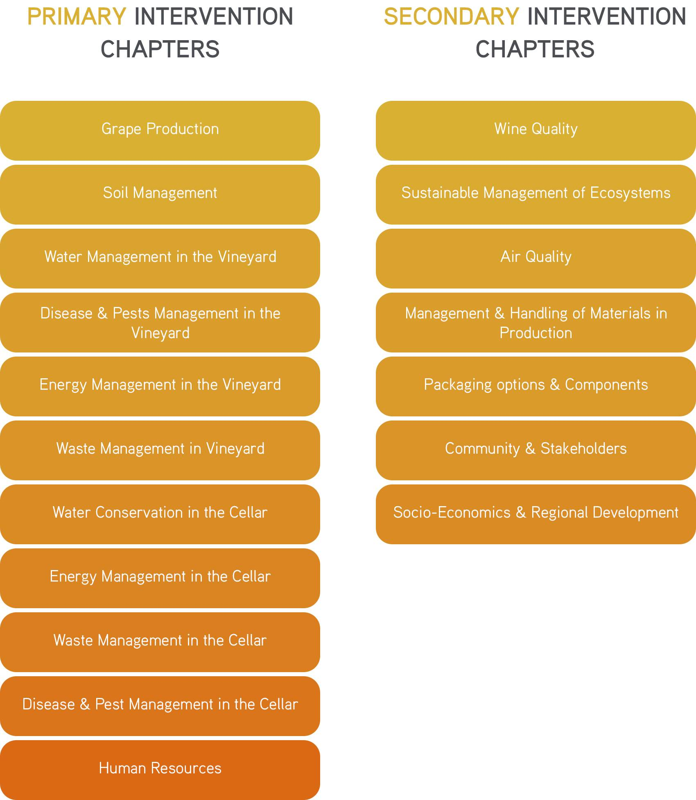
Source: http://sustentabilidade.vinhosdoalentejo.pt/en/wines-of-alentejo-sustainability-programme
The objectives that had been originally set in the original WASP proposal are being largely achieved but not fully as planned, especially in view of the original targets set within the Alentejo 2020 funding program under which the WASP had originally been designed and funded. Due to its links to this Regional Funding Program, the WASP has been audited twice. As a result of these audits it became evident that the WASP was already reaching far beyond the requirements in the funding program, with the minimum standards required for producers to participate in the WASP being well above those indicated in the Portuguese legislation for sustainable agriculture.
Figure 2. Examples of the 108 (self-)assessment criteria defined for the 11 Primary Intervention Chapters of the WASP.
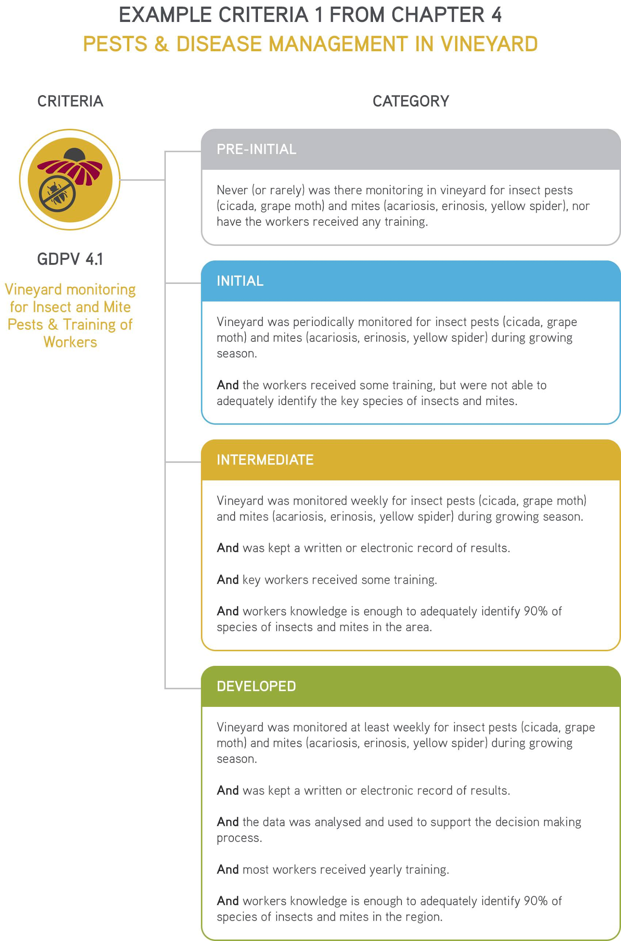 | 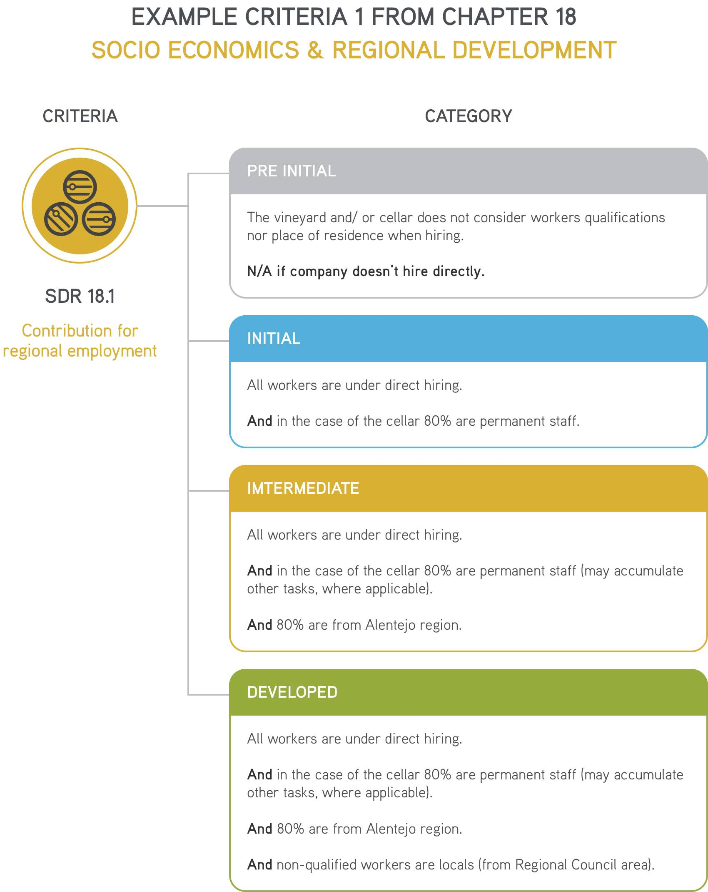
Source: http://sustentabilidade.vinhosdoalentejo.pt/en/wines-of-alentejo-sustainability-programme
However, the ultimate goal for every WASP member is to achieve continuous improvement of their sustainability standards and thus opportunities for improvement are always considered. Such opportunities are continuously revised as part of annual action plans, that are periodically reshaped according to any new knowledge acquired, and that aim for producers each WASP member to achieve the status of “Outstanding”. Once each WASP member has reached this status, 7 Secondary Intervention Chapters, including a total of 63 sustainability assessment Criteria are defined as new targets to be achieved individually, thus permitting tailored plans. Currently, the WASP includes a total of 18 Intervention Chapters with 171 evaluation criteria in total (http://sustentabilidade.vinhosdoalentejo.pt/en/wines-of-alentejo-sustainability-programme).
Once it has been clearly established the category to which each WASP belongs at a certain moment, the Secondary Intervention Chapters can become available for them to apply. A third-party external validation and recognition will only proceed when the WASP member achieves the Final Category of “Developed” in the Secondary Intervention Chapter (figure 3).
Figure 3: Thresholds of values required for the achievement of the various categories of Sustainability status for producers, ending with the “Developed” one towards which all participants must continuously work.
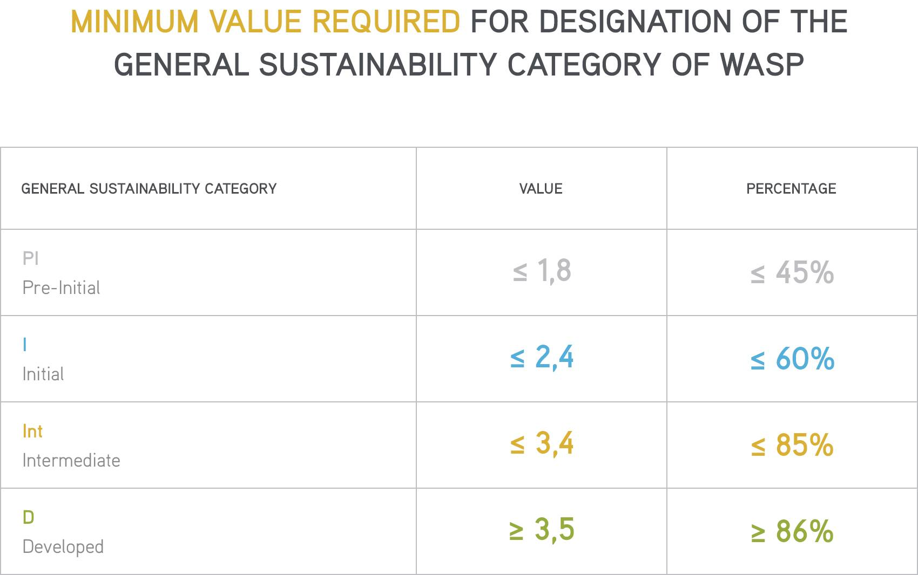
Source: http://sustentabilidade.vinhosdoalentejo.pt/en/wines-of-alentejo-sustainability-programme
In order to ensure credibility and reliability of the project, the results of the self-evaluation for each WASP member are subjected to an internal audit by the Alentejo Regional Wine Growing Commission. The self-evaluation will serve as an annual individual diagnosis on the sustainable practices of WASP members.
The ultimate goal for every WASP member is to work towards their own continuous improvement in order to ultimately reach the General Sustainability Category of ‘Developed’.

3.2. Qualitative assessment

The methodological approach that we defined to qualitatively elicit interactive innovation in the WASP includes collecting data on five interactions, for each of which it would be then necessary to identify and characterize the actors, structures, functions, institutions and good practices involved.
These 5 interactions are the following: 1. funding mechanisms; 2. internal project interactions; 3. external project interactions; 4. policy environment and 5. societal challenges.
To gather this information the first action was planned based on desk research.
1) Desk-based research. This first step was intended: i) to collect information about the WASP project implementation in general and its diverse stages, funding and outreach; ii) to gather publicly available information about the program (including technical reports and publications by the Universidade de Évora over the initial stage of the WASP) and about other similar activities by the coordinator and each of the partners; iii) to identify the legal and economic status of WASP partners, the geographical scope where they perform their activities and also about legal and economic relationships between them; iv) To gain an initial overview of the social, cultural, economic and policy context on which the WASP is framed.
The main sources of information for this first stage of research included the following:
a. WASP Website program information + project management documents and deliverables provided by the partners (CVRA + University + ATEVA)
b. Social Media: CVRA, ATEVA, Individual Producers
c. Newspapers articles: Little so far, as not too much info is published periodically (and mainly sporadically)
d. Scientific papers: Some links provided by the University of Évora team that worked on the project and also by an entity from Sweden (U. Lund) that academically cooperated with the program over its initial stage
e. Others: Periodic statistical datasets and periodic reports provided by the program coordinators (CVRA)
2) In depth interviews with those people identified as key actors of relevance to the 5 interactions. To select relevant actors and good informants, four actor clusters were preliminary identified: 1. Wine producers´ associations in the region, including ATEVA (Technical Association of Vine Farmers of Alentejo) and CVRA (Wine and Vine Commission of the Alentejo region); 2. Academic entities involved in the WASP, especially the Universidade de Évora (involved in the initial and publicly funded stage) and Lund University (involved later on along the implementation stage) and also others indirectly engaged; 3. Innovative farmers, firms and cooperatives from Alentejo engaged in the program and in charge of both or either wine production and vine cultivation 4. Public entities involved with the WASP throughout the initial (publicly-funded) and the follow-up (self-funded) phases, and that thus ought to be considered as external stakeholders.
The individual interviews were in all cases conducted online (except the 3 initial ones, which were performed live), recorded and each interviewee was furthermore asked to comment on our interpretation of the findings. Following a first preliminary live interview with the project leader, different models of interview templates were designed and delivered to all engaged project partners , beneficiaries/participants, external stakeholders and funding bodies.
Some additional interviews were also arranged with these and other relevant actors to perform a Social Network Analysis (SNA) that will allow us to identify and evaluate mutual relationships and linkages amongst diverse actors and institutions along the diverse stages of the project.
3) Lastly, and in addition to the two former steps, a participatory (online) workshop with key actors (10) was conducted on the 22nd July 2020 to evaluate and refine the findings, and especially to try to identify and disentangle future options for improving interactive innovation in the WASP. Actors involved in the workshop include the main actors already interviewed plus a selection of those additional actors involved in the SNA.

4. Results of WASP’s quantitative assessment
Planning for the WASP started in 2013 and the Program was officially launched to producers in May 2015.
With a strategy based on actions requiring low investment leading to fast returning benefits (considered by the project leader and manager as “low hanging fruits”) the 11 Primary Intervention Chapters (PICs) were then released and made available to the wider public. This was done in order to demonstrate the clear benefits for Alentejo’s grape and wine producers of joining and implementing the WASP.
This strategy had almost immediate results, with the Programme gaining 93 members by the end of 2015, a number that has increased every year.
At the end of 2018, 7 new intervention chapters were opened- Secondary Intervention Chapters (SICs) - to members who had already reached the level required by implementing the 11 PICs.
With a very heterogeneous group of members (including a wide range of property sizes, economic and financial capacities, team sizes, objectives or strategies) the approach for continuous improvement adopted by the WASP allows members to develop and implement the Programme at their own speed.

4.1. How numbers have evolved
The CVRA conducted two assessments of the regional implementation of the WASP.
The CVRA firstly assessed the implementation and continuous improvement of the 11 Primary Intervention Chapters (PICs) on a regional basis up until 2018. This evaluation was later expanded to include the 7 Secondary Intervention Chapters (SICs) in 2019 (figure 4).
When analysing the PIC evaluations synthesized as spider graphs, it becomes self-evident that the existing participants extend and compress their different sustainability impacts following a somehow apparently random pattern. This is due to two characteristics of the WASP: the continuous improvement model (which makes the values for each member’s evaluation increase, subsequently “expanding” the graph) and the constant increase in new members (causing the implemented level of sustainability to decrease, due to the lack or too recent implementation of required sustainability measures, subsequently “contracting” the graph).

Figure 4. Results of the primary and secondary intervention chapters
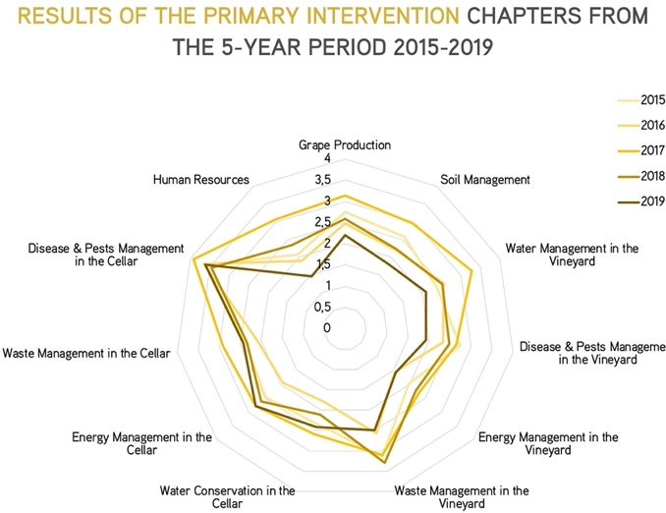  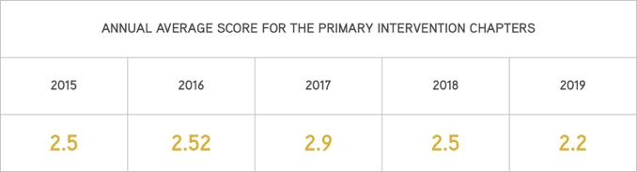 | 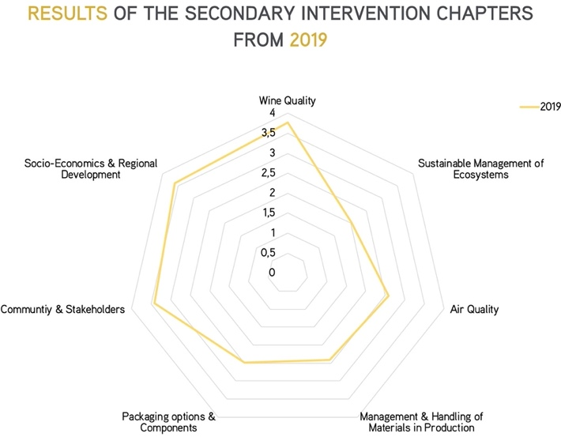  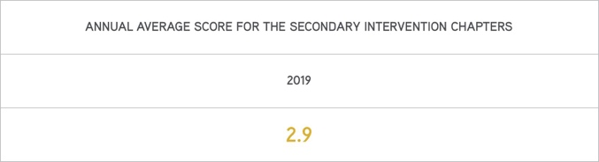
Source: http://sustentabilidade.vinhosdoalentejo.pt/en/wines-of-alentejo-sustainability-programme

5. Results of WASP’s qualitative assessment

Results and lessons learnt from the qualitative assessment of interactive innovation for sustainability within the WASP allowed us to focus on certain aspects that have been, so-far, largely under-considered such as the key role of individual champions in steering more dynamic leading by example, of open-ended stakeholder networks for knowledge and action co-construction, the sheer importance of shared values, and lastly the relevance of horizontal cooperation (amongst farmers) and vertical coordination (along the value chain) for sustainability purposes.

5.1. Dynamic Leadership
Dynamic leadership in interactive innovation projects can be the key to actually creating innovation. According to our results in the analysis of interactive innovation in the WASP, the presence of a leader or champion (in this case, the PSVA leader from the beginning of the project) has been crucial for achieving the following targets: 1) identifying the institutional support required for success, 2) generating trust and boosting motivation by engaging key stakeholders in the decision making process and in the development of novel product and practices, 3) expanding and diversifying the network of participants, 4) disseminating and embedding innovation across a variety of contexts and realms; and 5) advancing the perspective beyond ‘project-term’ funding towards longer term programs.
This champion had close working relationships with the organization’s management so he could influence decision-making processes and had autonomy to: establish contacts and alliances with partners, stakeholders and external actors; to coordinate the project; and to organize knowledge and information sharing.
Communication within the project has been largely valued as being very good, the key reason being the competence of the coordinator, who acts as catalyst to facilitate moving forward. Constant work is required for the revitalization of what has already been committed and has not yet been fulfilled, or what has been done and should continue because it was a success, and lastly, also of what has not yet been done, but could and even should potentially be done.
It seems apparent that the champion could not be easily replaced because he acts as change agent, rather than manager, so his loss before the project entering a routine could lead to a loss of enthusiasm and undermined the success of the project.
The ability of a person to become a champion comes from their soft skills: their charisma and the form in which they engage and inspire others, rather than the content of what they communicate.

5.2. Shared Values
Arising from our analysis, it seems evident that defining a vision based on shared values is an important step for interactive innovation projects, and that ultimately, shared values trigger enhanced sustainability actions and foster more effective participation.
A first relevant point is that sharing values provides a common perspective. Shared values have acted as a framework underpinning common objectives, actions and activities. Additionally, they enhance internal relationships, fostering trust and driving behaviors, routines and preferences. We found that shared values may lead farmers to tackle risks by adapting their practices to new challenges arising.
But, how were shared values created in this case? A first set of values was established when the project was originally devised. Sharing these initial values turns the execution of projects simpler, faster and more consistent. Additionally, we found that some values arise along a project, via active listening across stakeholders, cooperating and sharing knowledge, although this may result in tensions.
Resuming, shared values trigger mutual trust and foster cooperation, whilst cooperation also fosters the creation of shared values.

5.3. Stakeholder engagement: Network evolution process over time
The key barrier encountered by the project has been the cultural and mind-set aspects of local farming discourses, which are largely underpinned by conservatism and a related reticence towards changes and innovations. In Portugal this aspect may be a deciding factor compared to the US or Australia, where other similar Sustainability programs are in place for the wine sector. The Alentejo, despite being a region with an urgent need to innovate, is still a region with a farming community largely afraid of the unknown (Pinto-Correia et al, 2019), and therefore constant work is needed to raise awareness across producers about the added value of any innovative project, including this one. This currently being a voluntary and free project, certain barriers exist that need overcoming. In order to achieve its goals, those invited to speak at workshops or other events are always the producers. In fact, the active commitment of stakeholders in the WASP network is a key factor for its continuity, deepening the dissemination of results and fostering new innovations.
One of the key role project managers have performed is to monitor the network and to identify who the most active and critical stakeholders are, and those who are not. Carrying out this exercise in successive stages along the project shows how the initial network evolves.
Firstly, networks have possibilities to expand their results if the initial design relies on a central stakeholder that has a reputation, an established structure of relationships in the territory, and is independent of the project's resources.
The business orientation of the key stakeholders is the second factor to consider. This stakeholder acts by aligning the whole process towards applicable results and gets involved in the dissemination and recruitment of new participants, thus promoting the continuity of the work. On the contrary, if that stakeholder has a strong project orientation, the focus is on the expected results and the effort slows down once the funding ends.
Finally, as a third factor, it is likely that some more peripheral stakeholders with the capacity to promote, finance, and disseminate, can join actively when projects are focused on mature sectors. For this reason, the participation of the above type of stakeholders is even more important when we are dealing with pioneering activities, and/or scenarios with low density of stakeholders.

6. Final Reflections and conclusions
Sustainability programs for the wine sector have been in place for over 30 years and are rapidly spreading under a paradigm shift where co-constructing innovation as a strategy is key for gaining market power in a rapidly globalized world. Such programs are, so far, largely focused on quantitatively monitoring the sustainability of voluntary producers and other actors along the value-chain, via the use of quantitative indicators and standards that allow for a certain trademark to be collectively secured incurring in individual competitive advantages. This is a key aspect to consider when aiming for a paradigmatic shift in a sector that remains largely conservative and reticent to other forms of innovation other than technological. It is important, that to become effective in the mid- to longer-term, other more qualitative aspects should also be considered that have, so far, been miss-represented, or inadequately considered. Based on the case study here described (WASP), such aspects include, issues related to leadership, sharing values, and enhancing networking and stakeholder engagement, all of which seem to have been successfully fostered in this case via the incentives for participation and continuation that, throughout the various phases of the program, the managers have been putting in place.
Another key factor influencing success in this specific case, is related to the open-ended and flexible nature of the program. Nonetheless, it must also be said that the next big step is to reach enough critical mass (considered by the program managers as more than 60% of the wine-sector economic agents of the Alentejo) to be able to convert this free and voluntary project into a mandatory and free project. In the short and medium term, the goal of the WASP current managers is to gain the certification of the project by a 3rd party, that is, from an outsider that can say independently and without any bias whether the project is worthy and deserves to be acknowledged.
Based on this, some questions arise regarding the current impact of interactive innovations on the long term: will the actions taken so far be enough to reach the threshold of engagement and commitment required to move the whole sector towards enhanced levels of sustainability as a whole?; how are the pre-conditions and factors for success determined by the contingent socio-cultural conditions that define each regional wine sector and network of actors?; and, in case some of these conditions fail, how could the current levels of success be secured?, perhaps by establishing a trademark linked to sustainability that reassures the commitment of participants who are worried about their own financial resilience and competitiveness?
All this being said, the success of the program so far may also be used as an example, not just for the wine sector itself, but also to inspire and motivate others across the wider farming mosaic of the region where, similarly to most other Mediterranean regions, key sustainability challenges are threatening the immediate survival of key farming and food systems and related ecosystems (Prosperi et al, 2014). Such challenges include climate change, biodiversity and soil loss, population ageing and the permanence of a largely conservative mindsets. All of this, along with the lack of a clear strategy to cope more efficiently with the globalization of the sector, are jointly putting in peril the valuable and multi-functional landscapes and “terroirs” that over the past couple of millennia have been co-produced by multiple stakeholders acting in balance.
Acknowledgements
The authors would like to thank the European Commission, which through its H2020-funded LIAISON project (Grant agreement ID: 773418), has funded the qualitative and theoretical research condensed in this chapter. Furthermore, the CVRA, which through its WASP program, and with initial funds from the Alentejo 2020 program also facilitated the implementation of the quantitative research hereby shown. Additionally, the research hereby synthesized was also partially funded by National Portuguese Funds through FCT - Foundation for Science and Technology (Portugal), under the Project UIDB/05183/2020.
Last, we would like to thank Prof. Miguel Costa, from the ISA-Lisbon, for inviting us to publish our research in this book, and to the 2 reviewers who allowed us to improve our text and figures, to make them publishable.

References
Bonjean, I., & Mathijs, E. (2016). How transaction costs shape market power: conceptualization and policy implications. In 12th European IFSA Symposium, Programme and Book of Abstracts, Social and technological transformation of farming systems: Diverging and converging pathways (p. 107). Newport: IFSA.
Buller, H., van Dijk, L., Fieldsend, A and Varga, E. 2019. “D.1.1. Moving Innovation from the Sporadic to Systemic: Innovation Governance Strategy, Approaches and Practices and role of different actors and governance bodies on Global and International Scale. H2020 LIAISON Project. GA no. 77341
COM, 2014. Communication from the commission to the European Parliament, the Council, the European economic and social committee and the committee of the regions. Research and innovation as sources of renewed growth. Brussels, 10.6.2014. 339 final
Cronin, E., Foselle, S., Fieldsend, A., Menet, A., Couzy, C., Rogge, El., & S. Von Münchaussen (2020). Deliverable 4.1. 32 Case Study Portraits, with Practice Abstracts, of Interactive Innovation projects and initiatives across Europe. LIAISON-H2020 Project [https://liaison2020.eu/wp-content/uploads/2021/01/Deliverable-4.1-Case-Study-Portraits.pdf]
CVRA, 2020. Comissão Vitivinícola Regional Alentejana. RELATÓRIO ANUAL 2019: Gestão e Contas
European Evaluation Helpdesk for Rural Development, 2017. Evaluation of Innovation in Rural Development Programmes 2014-2020.
Francis, C., Lieblein, G., Gliessman, S., Breland, T. A., Creamer, N., Harwood, R., ... & Poincelot, R. (2003). Agroecology: The ecology of food systems. Journal of sustainable agriculture, 22(3), 99-118.
Ingram, J., Maye, D., Kirwan, J., Curry, N., & Kubinakova, K. (2015). Interactions between niche and regime: an analysis of learning and innovation networks for sustainable agriculture across Europe. The Journal of Agricultural Education and Extension, 21(1), 55-71.
IVV, 2019. Instituto da Vinha e do Vinho. Reforma da PAC 2021-2027 plano estratégico da PAC análise sectorial: vinho. Contributo IVV, IP
Klerkx, L., Aarts,N. and Leeuwis, C. (2010). Adaptive management in agricultural innovation systems: The interactions between innovation networks and their environment. Agricultural Systems 103(6): 390-400
Knickel, K., Brunori, G., Rand, S., & Proost, J. (2009). Towards a better conceptual framework for innovation processes in agriculture and rural development: from linear models to systemic approaches. Journal of Agricultural Education and Extension, 15(2), 131-146.
Martins, A. A., Costa, M. C., Araújo, A. R., Morgado, A., Pereira, J. M., Fontes, N., ... & Mata, T. M. (2019). Sustainability evaluation of a Portuguese “terroir” wine. In BIO Web of Conferences (Vol. 12, p. 03017). EDP Sciences.
Merli, R., Preziosi, M., & Acampora, A. (2018). Sustainability experiences in the wine sector: toward the development of an international indicators system. Journal of cleaner production, 172, 3791-3805.
Neumeier, S. (2012). Why do Social Innovations in Rural Development Matter and Should They be Considered More Seriously in Rural Development Research? – Proposal for a Stronger Focus on Social Innovations in Rural Development Research. Sociologia Ruralis 52 (1), 48-69.
Ohmart, C. (2008). Innovative outreach increases adoption of sustainable winegrowing practices in Lodi region. California agriculture, 62(4), 142-147.
Prosperi, P., Allen, T., Padilla, M., Peri, I., & Cogill, B. (2014). Sustainability and food & nutrition security: A vulnerability assessment framework for the Mediterranean region. Sage Open, 4(2), 2158244014539169.
Santiago-Brown, I., Metcalfe, A., Jerram, C., & Collins, C. (2015). Sustainability assessment in wine-grape growing in the new world: Economic, environmental, and social indicators for agricultural businesses. Sustainability, 7(7), 8178-8204.
Santini, C., Cavicchi, A., & Casini, L. (2013). Sustainability in the wine industry: key questions and research trends a. Agricultural and Food Economics, 1(1), 1-14.

