Landscapes and Landforms of the Beira Baixa Region (Sarzedas–Monfortinho, Eastern Central Mainland Portugal)
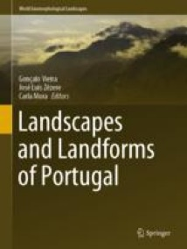
Authors
Authors and affiliations
Pedro P. Cunha António A. Martins Alberto Gomes David R. Bridgland

Chapter
First Online: 23 May 2020
Part of the World Geomorphological Landscapes book series (WGLC)
Abstract
The Beira Baixa is a low-relief region that is transitional between the Portuguese Central Range and the South Portugal Planation Surface. The main regional geomorphological unit is a planation surface cut on the phylites/metagreywackes of the basement, locally with granite inselbergs and quartzite ridges. Tectonic landforms are represented, such as fault scarps and fault valleys, and the main fault scarps are associated with the Ponsul and Sobreira Formosa Faults. The culminant surface of the Lower Tejo Cenozoic Basin is preserved as residual sedimentary relief, being the sedimentary surface of alluvial fans or Atlantic rivers prior to incision. Fluvial landforms related to the incision stage are well represented, such as epigenetic valleys, gorges, incised meanders, and strath terraces. The limited human occupation has resulted in many diversified natural landscapes being well preserved and thus available for observation, providing a detailed geomorphological record of the complex Cenozoic geological evolution.

Keywords
Planation surface Resistant ridges Fault scarp Piedmont Residual sedimentary relief Fluvial incision

