Landscape Character Assessment across scales: insights from the Portuguese experience on LCA in policy and planning

Isabel Loupa Ramos, IST, Universidade de Lisboa, isabel.ramos@tecnico.ulisboa.pt
Teresa Pinto Correia, ICAAM, University of Évora, mtpc@uevora.pt

Synopsis

This chapter aims at providing insights on the challenges arising from articulating LCA across scales in Portugal. Landscape is already acknowledged in Portuguese legislation since the 1976 constitution - article 66 on the right to quality of life. Despite some experiences in identifying and characterizing landscapes at an ad hoc basis, only following the signature of the European Landscape Convention the Portuguese public authorities called for a systematic approach covering the whole territory. A LCA was carried out using a combination of automated GIS analysis, together with interpretative refinement by experts and regional stakeholders, producing a nation-wide map at 1:250,000 scale. This work, published in 2004, still sets a milestone is LCA approaches in Portugal. The final map has been used (in varying degree) to inform policies in multiple sectors, as agriculture and forestry, heritage, nature conservation and spatial planning. However, the latter stands out. The Directorate responsible for spatial planning represents Portugal in the Convention and establishes since 1999 legislation and guidelines for the use LCA in spatial planning documents – those of strategic nature, as regional planning documents (NUT 2 level) and at local land use plans (LAU 1 level) as Municipal Master Plans – typically, zoning plans at 1:25,000 or 1:10,000 scale, including both rural and urban areas.
This chapter draws on the authors’ experience in carrying out LCA across scales and landscape types – from national to urban scale and from deep rural to urban landscapes. Besides the nation-wide approach, other local experiences are scrutinized and used as example.
As there is far more experience and literature in LCA at broad-scale rural or natural landscapes, methodological approaches need to be reviewed and adapted in the downscaling process to urban landscapes. Thus, this chapter aims at discussing arising issues, as for instance: what landscape characteristics and features should be considered relevant to the identity of the landscape at each scale, how to articulate landscape and administrative boundaries, how to decide who is the relevant “public” or how to bridge the gap between science and practice, meaning, how to ensure the usefulness of LCA in the overall planning process without compromising conceptual aspects. Ultimately, the main challenge is ensuring coherence and consistency across scales and simultaneously avoiding losing specificity of the local context. Concluding, the authors wish to reflect on how this downscaling experience can also provide useful insights on how to upscale in the progress towards a European LCA approach.

1. Introduction: landscape in policy and planning practice

Landscape is acknowledged in Portuguese legislation since the 1976 constitution – in article 66 on the right to quality of life. Since then landscape has made its way into the discourse of fundamental policy documents in different sectors of public administration, notably environment policy, agriculture policy, forest policy, cultural policy and spatial planning policies.
Environment policy was the first to embrace landscape and to imprint the first definition of landscape into Portuguese legislation. In 1987 landscape was defined as “a geographic, ecologic and aesthetic unit, resulting from the action of people and the reaction of nature. Landscape is primitive when the action of people is minimal and natural when peoples’ action is dominant but without promising the ecological equilibrium, the physical stability and the ecological dynamics”.

This initiative is not surprising as in 80ties environment policy gained momentum in Portugal after the transposition of many European Directives following the 1986 accession of the country to the European Union. Landscape became relevant as compulsory descriptor in Environmental Impact Assessment studies. This approach extended in 2007 also Strategic Environment Assessment.
The nineties witnessed the introduction of landscape into agriculture and forest policy discourses, and also partially into their goals. Since 1992 the MacSharry reform of the Common Agriculture Policy introduced in Portugal the landscape concept into the agro-environmental measures, establishing measures that promote the rural landscape linked to sustainable agriculture practices – though not defining specific landscape goals. Also forestry law has acknowledged landscape in the first Forest Act of 1996 related to the role of the forests in improving the recreational value of landscape. This objective has been further developed in the legislation concerning the Regional Forest Plans (put in place between 2006 and 2007), which proposed an association of forest production system and landscape types. In Portugal this has taken place opposite to the 2006 European guiding documents – European Forest Strategy and Action Plan – which does not refer to landscape at all.
The 2001 Cultural Heritage Act mentions that objects should be preferably protected in the context of the wider landscape. In heritage policies traditionally only special landscapes found protection status notably those classified as world heritage by the UNESCO, as the cultural landscapes of Sintra and of the Douro and Pico vineyards, or special sites, as historical gardens.
Only in 1998 a comprehensive Act on Spatial Planning was approved. In this context landscape is very much linked to the promotion of quality of life. In 2007 the National Territorial Scheme called for a specific law on Architecture and Landscape, which is currently in discussion. This could be a unique opportunity to promote the landscape consideration as a specific object of the public intervention – but the document under discussion presented by the government focuses much more on the architecture and the build environment – and landscape architecture -, then on the overall landscape, and with this the landscape has been positioned into a second rang in the public attention.
Despite, the signature of the European Landscape Convention (COE, 2000) by Portugal in 2000 and its ratification in 2005 there were only some noticeable efforts for a more holistic approach. Amongst these outstand, for instance, the revision of the 1987 Environment Act in 2014 referring to landscape in the following way: “The safeguard of landscape implies the preservation of the aesthetic and visual identity, of the authenticity of natural values, heritage and of sites which support socio-cultural systems. The safeguard of landscape aims at the conservation of regional qualities which contribute to the national identity”. Still, the activities that shape and maintain or damage the landscape, are seldom integrated in the broader landscape understanding – and therefore also only partially integrated in sectorial legislation.

Landscape character areas (LCA) have firstly been integrated in the 1999 follow up legislation of spatial planning: the Spatial Planning Act. This Act established the framework for a variety of spatial plans at multiple scales – national, regional, local – for multiple sectors – like transportation, water management or tourism – and for special areas – as the coast or artificial lakes created by dams. In this context, only regional plans need to include landscape character assessments. But since 2011 guideline have been published by the institution responsible for spatial planning towards the integration of LCA also in local plans – notably in Municipal Master Plans.

In common language landscape in Portuguese - paisagem - has foremost a visual and aesthetic meaning – a portion of territory that can be viewed at one time from one place – a view or panorama – specially a beautiful view with a natural or rural scene (Porto Editora Dictionary). This popular understanding of landscape has found difficulties in matching the more academic definitions favoring of a more holistic perspective based on the relationship between culture and nature in a complex and dynamic system. This duality in definitions has left its marks on the way landscape has been considered in legislation and foremost on how it has been used in practice.

Based on the provided overview on integration of landscape in Portuguese legislation, it becomes evident that landscape approaches are legally binding as a compulsory descriptor in EIA/SIA and as LCA mapping in Regional Plans and more loosely in sectorial and local plans. The different approaches to landscape and the different levels of integration in the relevant sector legislation reflect in fact the lack of a clear vision for an integrated approach to the landscape, shared by all sectors. But still, the landscape is present in the legal documents and landscape units are used as basis for reading and understanding the territory. Typically, these landscape units have been defined based on expert judgment, overlaying available data sets with a strong emphasis on biophysical and land use/cover data, as reported by Groom (2005).

In this framework the present chapter aims at reporting on the experience of LCA at multiple scales as carried out since 2000 in Portugal. It draws on the authors’ experience in carrying out LCA mapping across scales and landscape types – from national to local scale and from deep rural to urban landscapes. It aims to explore how “scaling” is approached to fit the purpose of different planning documents. Scale is here used in the multiple senses provided by Herod (2011) – sense of size, power relationships or hierarchy. Thus, “downscaling” is not only meant in its literal sense of “making smaller” (e.g., Merriam-Webster) or the process of deriving finer resolution from coarser resolution, as it is typically used in cartographic exercises. Due to the holistic nature of the landscape concept itself, it might also mean not only using more detailed data sets but also different kinds of data sets that only become available at certain scales, integrating different perspectives and different observers that add new content according to the different objectives of each LCA map across scales. In this context, “across scales” is strongly associated to administrative units and therefore mainly to power relationships – planning documents at different levels of governance - national, regional and local.

In section 2 we explore how the nationwide LCA map produced in the follow up of the signature of ELC has been used in planning documents in national and regional levels, providing insights at NUTS1, NUTS2 and NUTS3 level. Section 3 reports on experiences of LCA mapping as it has been approached at the local scale – municipal planning level (LAU2). In section 4 challenges ahead are discussed on the “if” and “how” to progress with LCA mapping towards a more detailed urban scale and to a more generalized European scale.

2. From national to regional – mapping and integration in policy objectives

The LCA at national level, at a reference scale of 1:250.000, was produced at the start of the 2000’s, and published 2004 (Abreu et al. 2004; Pinto-Correia et al. 2003). Together with the national classification for the continental Portugal, also a classification of the Açores arquipelago was produced, though at a more detailed scale, 1:50.000. Only the arquipelago of Madeira was left out, mainly due to limitations in financing capacities.

The map produced is shown in Fig.1. The classification analysis started with an automate combination of existing data layers, as topography, morphology, soils, land cover, infrastructures, together with satellite images, producing a first draft of the different landscape units. These were used as support for a detailed classification, obtained through systematic field observations and the fulfillment of a landscape character register protocol. Experts at regional level were also consulted, in order to adjust the boundaries of the units to the acknowledged local character of the landscape. 128 landscape character areas (called in this context landscape units) were obtained, for the whole country. Each landscape character unit is thus unique and can be characterized individually by is own character. Only later, in order to operationalize the classification and stress similarities between the different landscape units, these units were organized in regional groups. 20 groups have been identified, with a more regional dimension and corresponding in broad terms to previously, more classical geographical classifications of the Portuguese territory in regions (Ribeiro 1987).
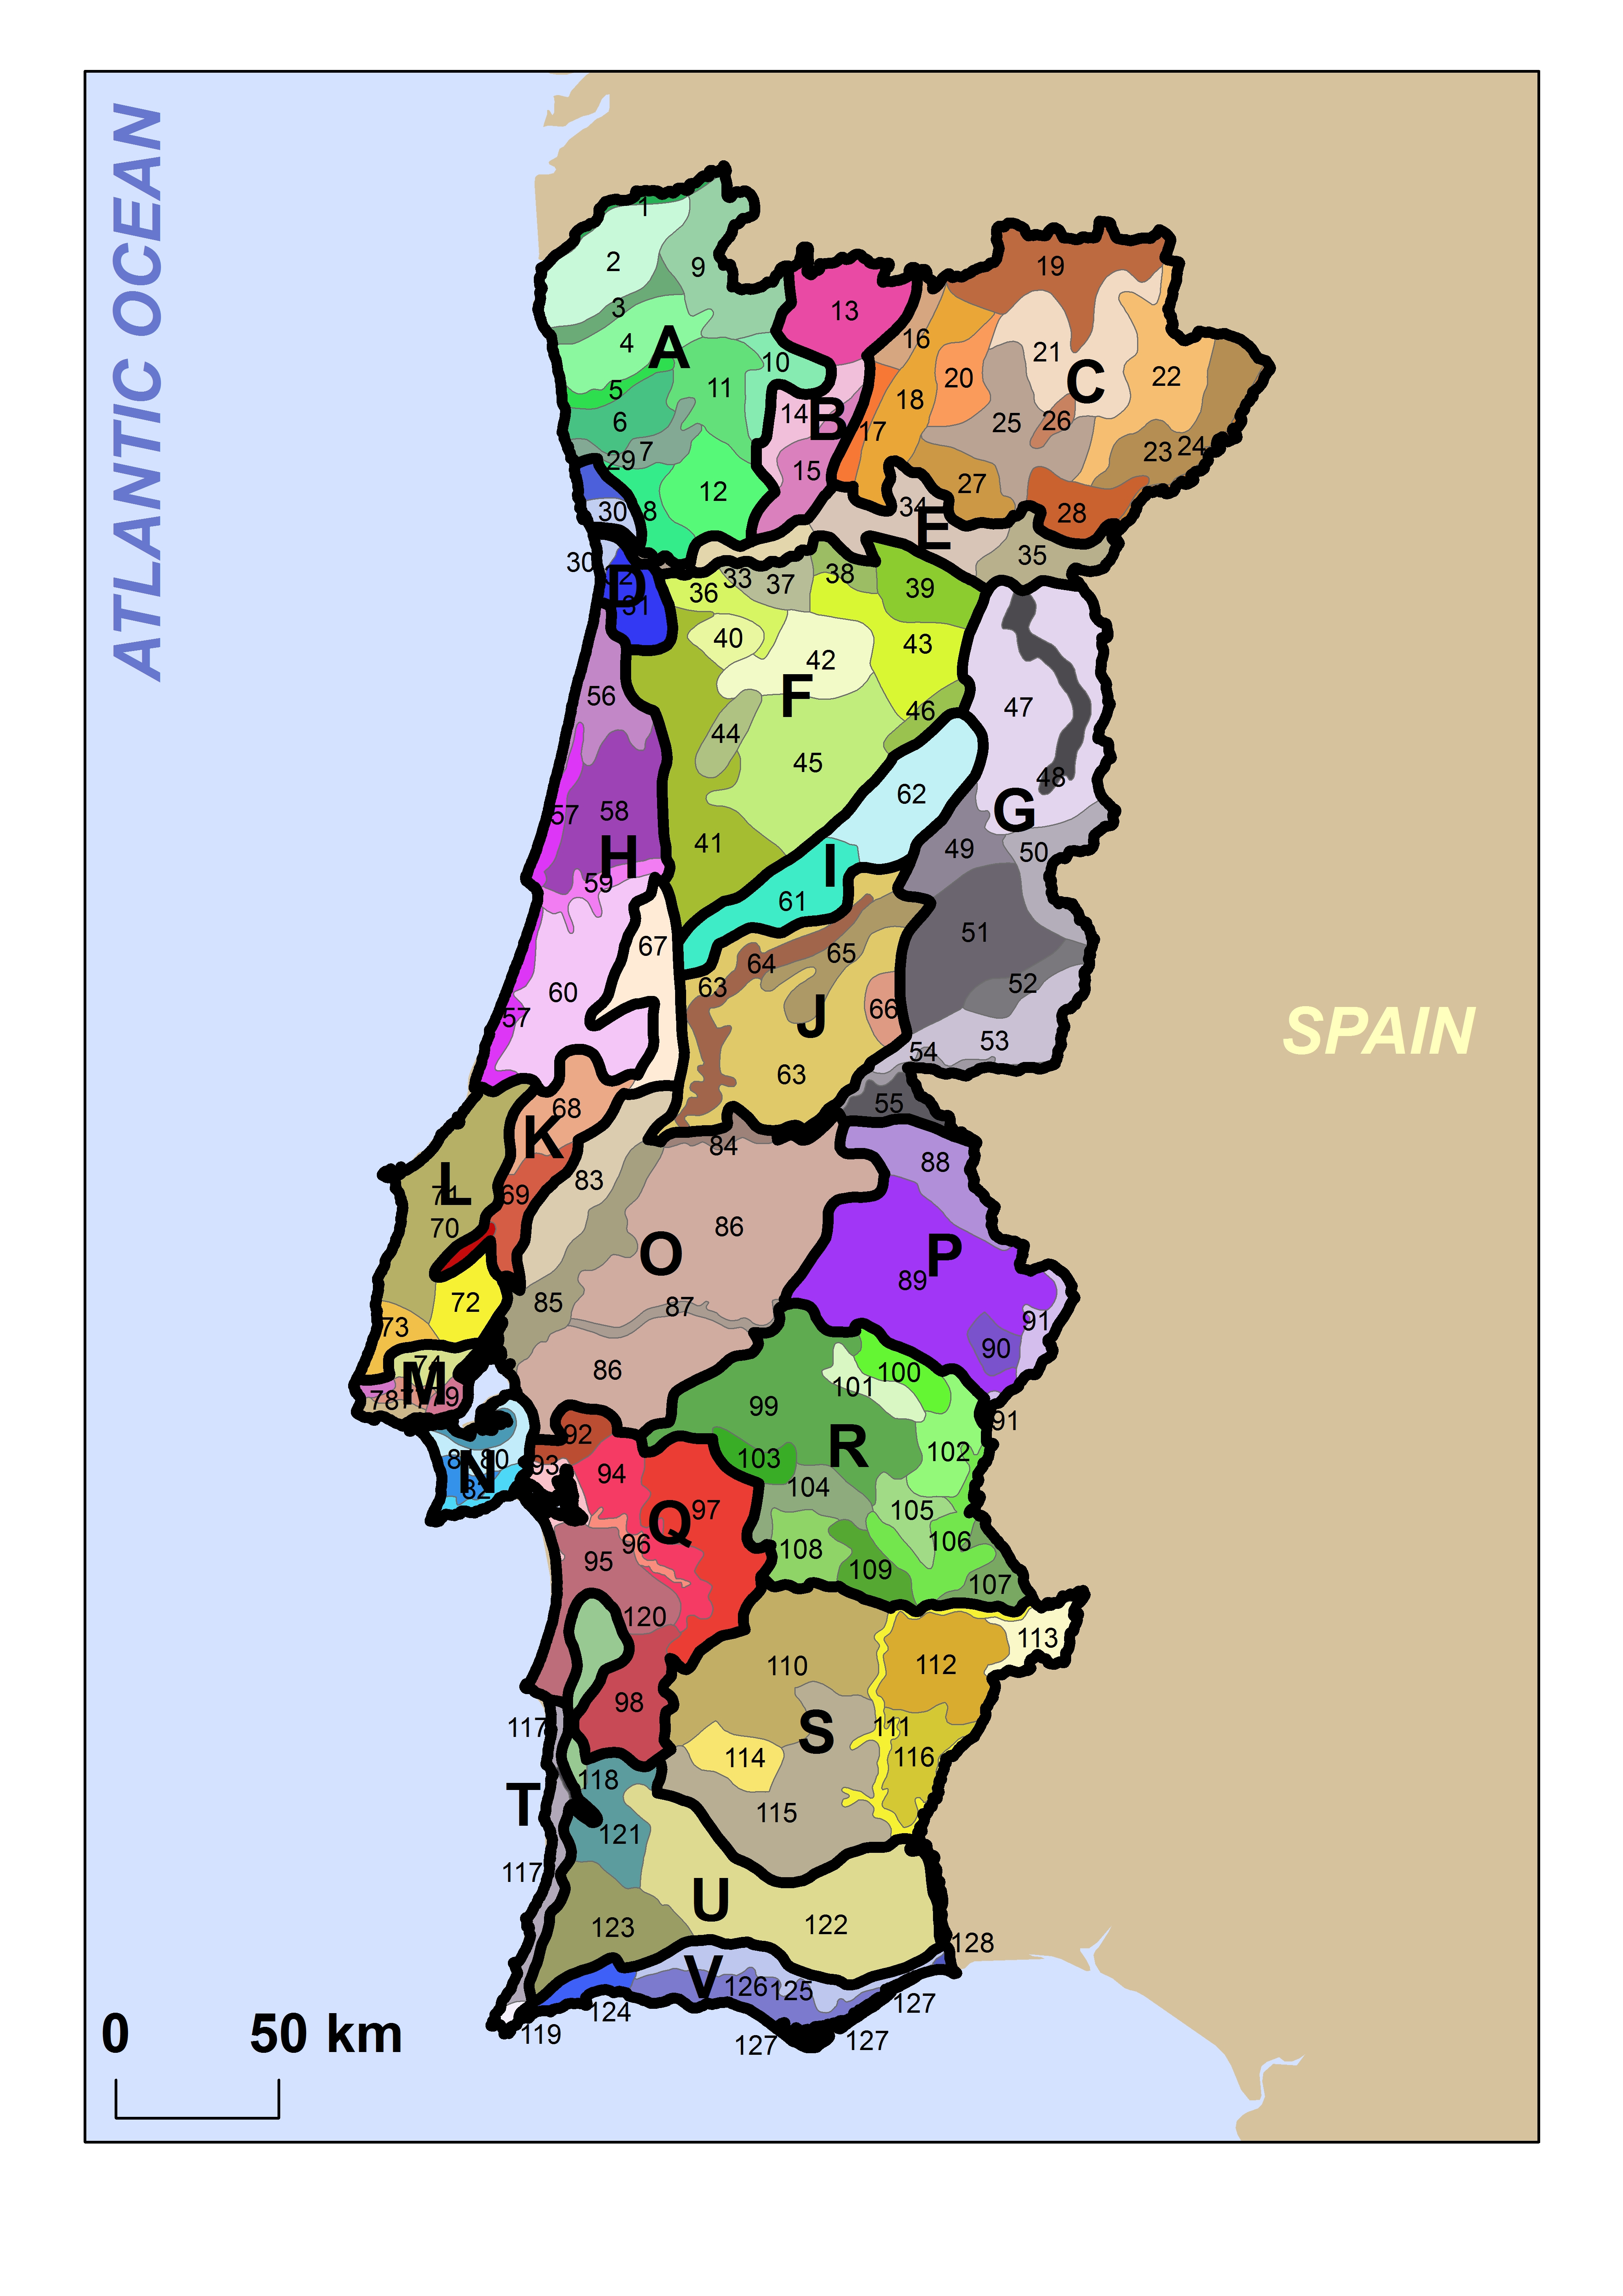
Fig.1: The landscape character units of Continental Portugal (according to Abreu et al 2004). The units are identified by numbers, and organized in large sub-regional groups, identified by capital letters.
A - Entre Douro e Minho; B - Montes entre Larouco e Marão; C - Trás-os-Montes; D - Área Metropolitana do Porto; E - Douro; F - Beira Alta; G - Beira Interior; H - Beira Litoral; I - Maciço Central; J - Pinhal do Centro; K - Maciços Calcários da Estremadura; L - Estremadura
- Oeste; M - Área Metropolitana de Lisboa (Norte); N - Área Metropolitana de Lisboa (Sul); O - Ribatejo; P - Alto Alentejo; Q - Terras do Sado; R - Alentejo Central; S - Baixo Alentejo; T - Costa Alentejana e Sudoeste Vicentino; U - Serras do Algarve e do Litoral Alentejano; V – Algarve. Note: there is no sharp relation to administrative units having the same name.

The procedure to obtain the national classification was significantly heavy, and the field work and expert consultancy demanded resources and especially a long time. But the resulting map has showed to be consensual and thus also widely use in further public intervention tools, as national, regional and local plans.

At the national level, the above shown map has been integrated in the PNPOT, the National Strategic Plan for a Spatial Planning Policy in Portugal. It has not been a background for any further analysis or strategy; it has simply been integrated as complementary information, mainly as the recognition of the differentiated and rich variety of landscapes in the Portuguese territory. It contributes thus to the picture of the country, more than to define future public intervention and orientation of private action.

Nevertheless, at regional level the landscape classification has been more clearly used. The landscape units produced in 2004 have both been the basis for the regional spatial plans, as well as for the regional forestry plans. The Regional Spatial Plans (PROT) are regional planning tools, compulsory according to the Spatial Planning Act. They are proposed and managed by the regional administration, e.g. the regional level of the central administration, on a sector basis. Thus, the entity responsible for the PROT is the regional spatial planning and environmental administration. All decisions concerning land use and land based activities need to respect this plan, once it is approved. Much more than the national plan (PNPOT), the regional plans are operational (even though still strategic), as they define goals, possibilities and thresholds for the regional territory, that are the ground for the specific administration of the public intervention - permissions and restrictions related to changes in land use by privates come only in force when these are transposed and inscribed in the Municipal Master Plans at local level.

In Fig.2 we show the example of the regional spatial plan for the region of Alentejo, a NUTS2 unit in Southern Portugal. The method applied was defined by the team working on this specific regional plan – as there was not a pre-defined methodological approach defined for all regional plans. Therefore in other regions, the use of the landscape character units may be different. On the left side of the figure, the landscape character units identified in the national classification are shown. The numbers refer to the national level identification of the units. In the right side, the landscape units as territorial homogeneous units, considered in the regional plan for the region: Regional Spatial Plan of Alentejo (PROTA), approved in 2010. These homogeneous territorial units are expressed in different colors and identified by letters (see legend); the boundaries of the national landscape character units are shown in grey, underneath the colors. It can be observed how the homogeneous units at regional level respect the same boundaries, but often result from the merge of different landscape units. The relevance of the landscape character units is thus recognized, but for operational goals of the plan, a lower level of detail has been adopted, and therefore the merging operation of the landscape units was needed. It is important to note that this is the first generation of regional plans where the landscape has been taken in consideration in this way according to the Spatial Planning Act of 1998 – before landscape was not so clearly on the agenda, and also because there was no landscape character units classification produced in a consistent way and acknowledged as valuable by different sectors and stakeholders.

For each homogeneous territorial unit, specific strategic goals and regulations are defined, for example as it regards the land cover mosaic, the land use activities, spreading of built areas, etc. The established goals and the respective regulations are clearly defined as consistent with the dominant landscape character in each unit. And thus, the landscape character has implicitly been integrated in the regional spatial planning. And will hopefully contribute to future developments that respect the landscape identity and quality.

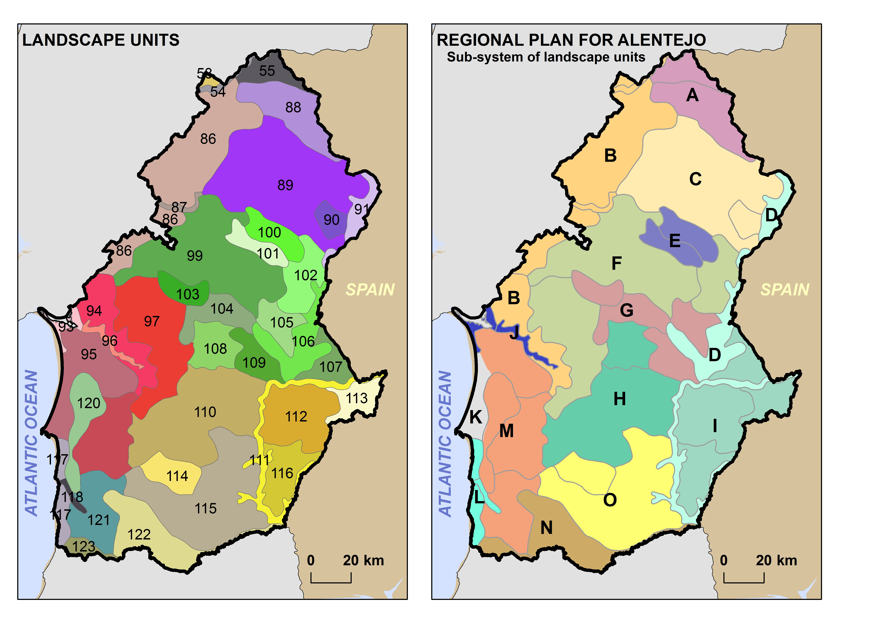
Fig.2: Example of the Alentejo region: the use of landscape character units, produced at national level (left side) to define the homogeneous territorial units of the regional plan (right side). The spatial planning homogeneous territorial units are identified by regionally acknowledge site names.
A: S. Mamede e Terras do Nisa; B: Charnecas do Tejo e Sado; C: Peneplanície do Alto Alentejo; D: Sistema do Guadiana; E: Zona dos Mármores; F: Montados; G: Zona central envolvente de Évora; H: Terras agrícolas (regadio do Alqueva); I: Margem esquerda do Guadiana; J: Estuário e vale do Sado; K: Planície litoral arenosa; L: Litoral alentejano e vale do Mira; M: Transição litoral/interior; N: Serras do Sul; O: Campos do Baixo Alentejo.

Another regional level application of the landscape character unit classification concerns the forestry plans at regional level, PROF. These sectoral plans do not respect the same NUTS2 level, but a specific lower level administrative unit used in the Portuguese agricultural and forestry administration. One example, relating to the central part of the Alentejo region, is shown in Fig.3. Here, the methodological approach to transfer the landscape character units into this planning tool, was defined in each region separately, by the regional level administration.

In the forestry plans, the landscape character was used to identify the main function of each unit – and therefore this landscape character has acquired a very determinant role in the forestry plan and related strategy for each spatial unit considered. In the frame of the regional forest plans for the Alentejo region, homogeneous areas were identified, based on the landscape character units (Abreu et al. 2004). The landscape character areas boundaries are used, though the homogeneity of these areas is also coherent with the ecological classification defined in the ecological map of the country, in 1954 (Albuquerque 1954), concerning altimetry, relief form, lithology and soil diagnosis characteristics. In each of these areas the five functionalities assigned, namely production, range grazing and game, protection, conservation and recreation, were ranked. The methodology of functionality ranking per homogeneous area was an algorithm, of statistical basis, which takes into account as parameters the occupied area, the average and the standard deviation per functionality and the product of the average by the area (Ferreira et al. 2008). The different functionalities coexist in the same territory revealing complementarities, contributing thus to the multi-benefit systems sustainability.

In this way, it is clear that these forestry plans put the landscape character classification in a prominent position, thus considering the landscape as the determinant for the way the forestry should be managed for the future – recognizing the territorial role of the forestry activity and land use. The same cannot be found for the agriculture sector, as there are currently no agriculture spatial plans, or regional territorial strategies. In fact, despite the official discourse where the landscape is considered as a product of agriculture, there is no grounded application of this discourse in practice (Pinto-Correia 2010; Pinto-Correia and Godinho 2013).

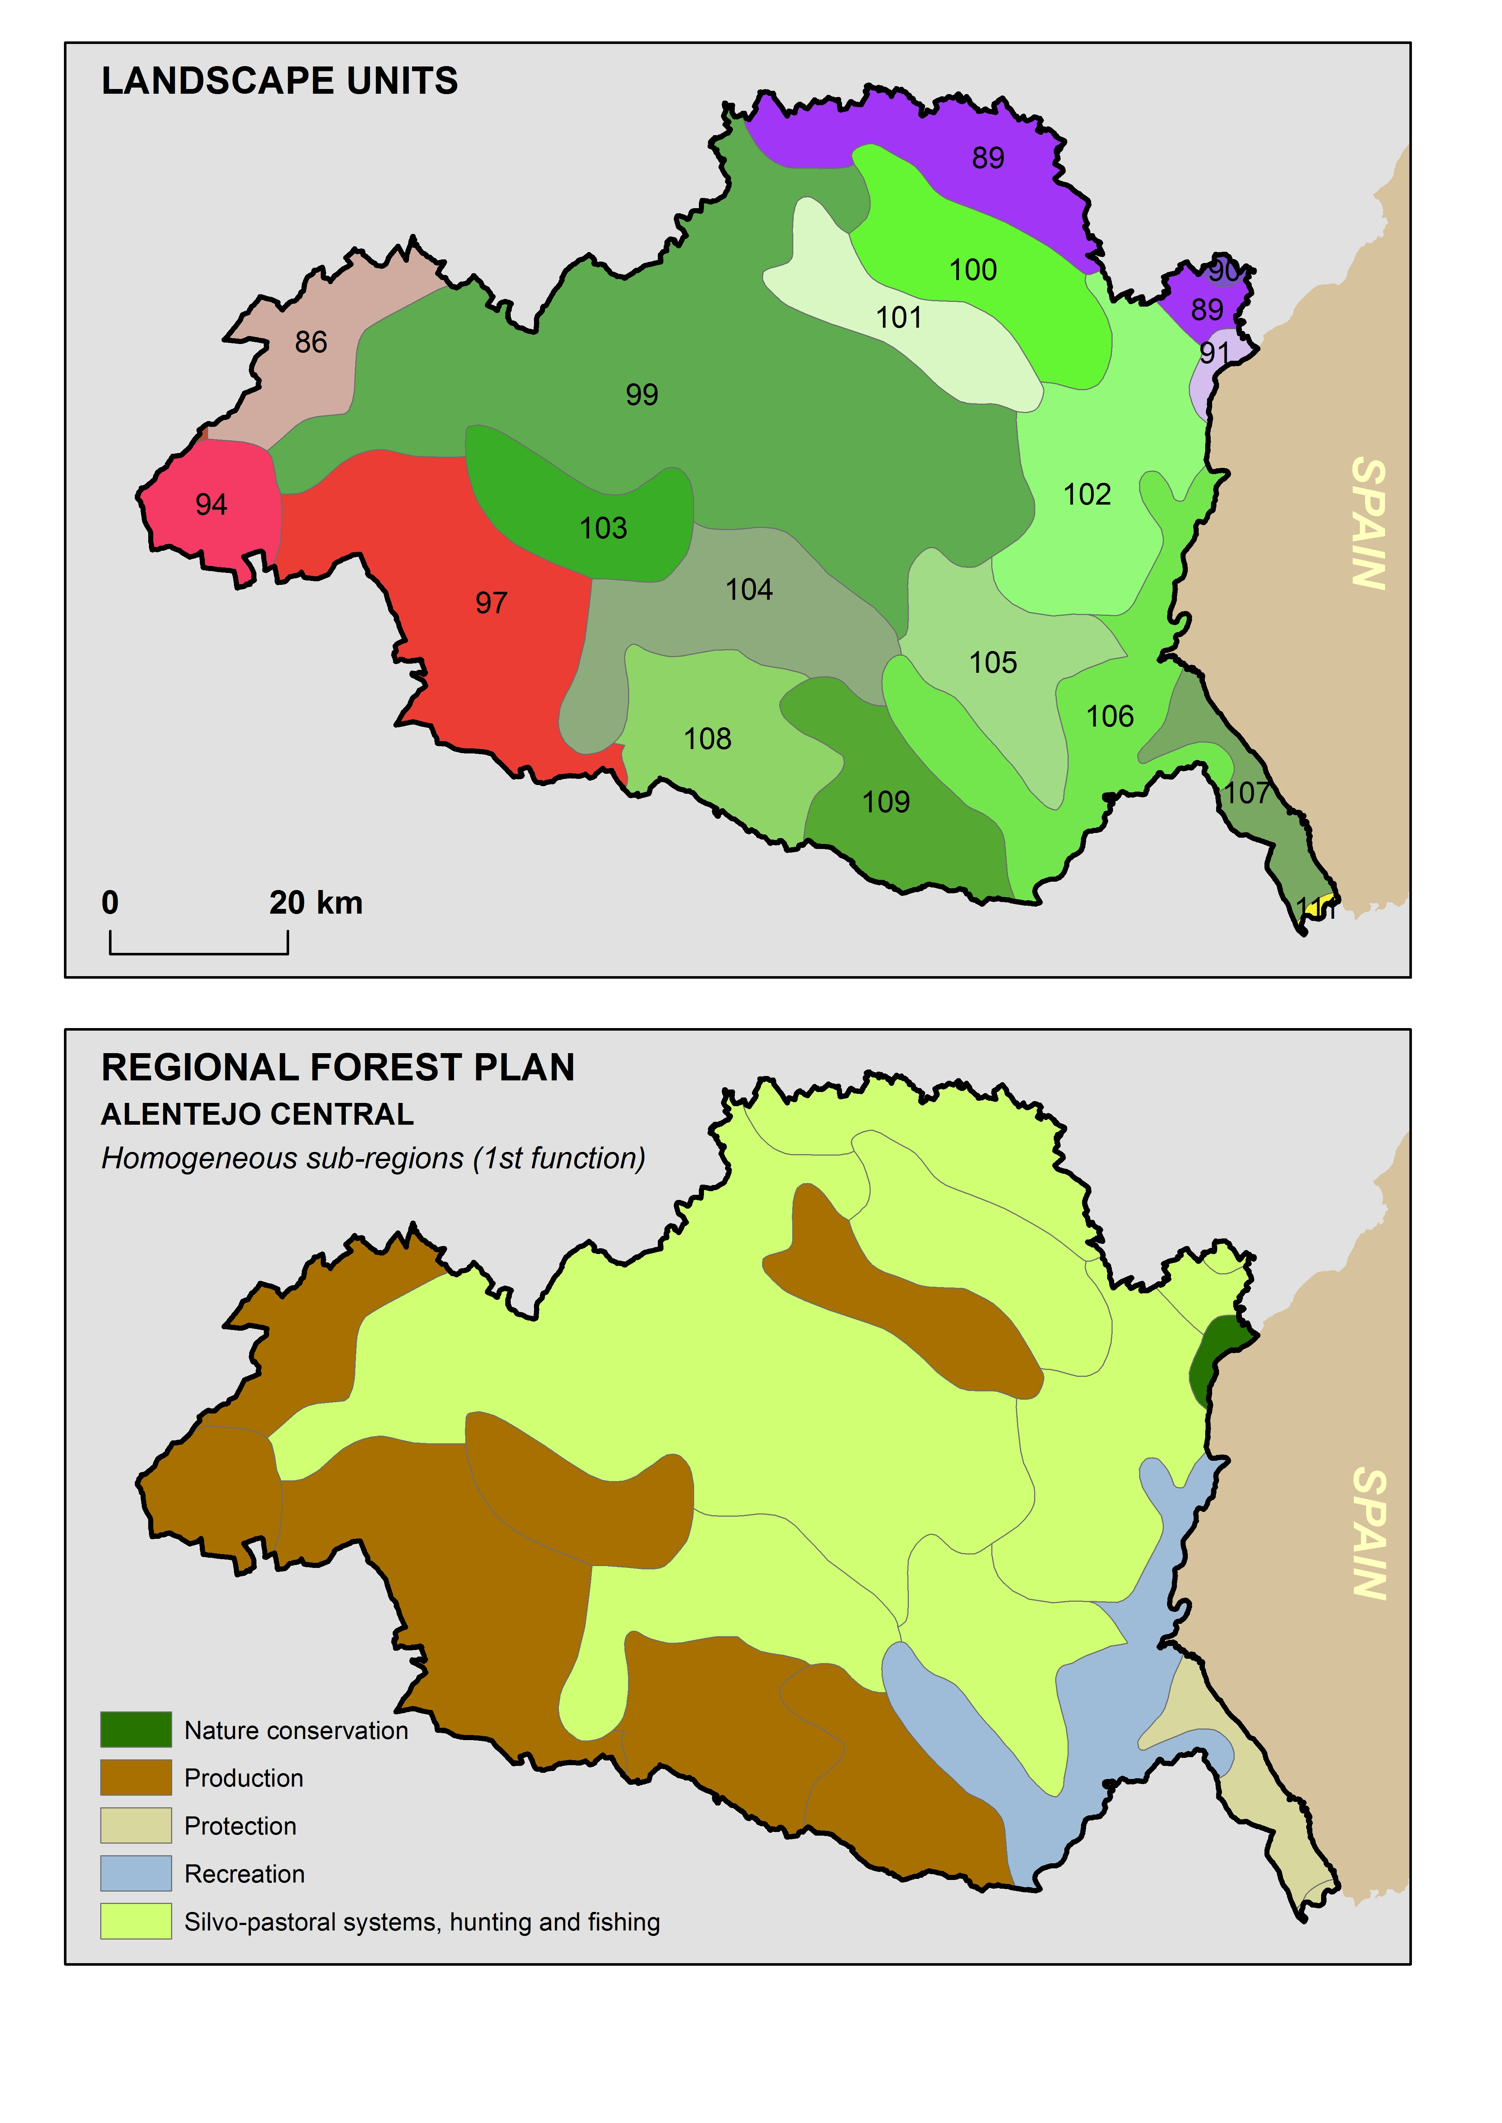

Fig.3 – The use of the landscape character units defined at national level, in the regional forestry plan of Central Alentejo. The units were grouped in homogeneous areas, according to the dominant function of the forest in the area: nature conservation, production, protection, recreation, silvo-pastoral systems, hunting and fishing.

3. LCA in local planning: integrating local knowledge bases

Municipal Master Plans in Portugal, unlike in other countries, cover both urban and rural areas. There are 308 municipalities in Portugal (mainland and islands), ranging from 7,9 km2 (São João da Madeira) to 1720,6 km2 (Odemira) with a mean value of 299 km2. Typically, municipalities include at least one urban area where the elected administration is located. MMP are called to address both urban and rural areas, and thus, LCA mapping is covering the whole area of the municipality. MMP are carried out at 1:25,000 scale or 1:10,000 in smaller or more urbanized municipalities. Most of the first generation MMP was put in place during the nineties. Having expired they legal 10-year period of validity at present many municipal plans are undergoing a review process and that will guide landscape change over the next decade. In 2011 the Portuguese institution responsible for spatial planning provided guidance for the integration of LCA in Municipal Master Plans (Abreu et al. 2011).

The focus of this section is concerned with the use of LCA mapping at local scale. It aims to report on experiences of LCA at local scale and to provide insights into arising challenges on how to ensure consistency across scales and how to collect and integrate the knowledge base of the local public and stakeholders. It draws from experience in case studies carried out by the authors in 3 municipalities in Portugal - Castelo de Vide, Almada and Setúbal (Fig. 4). Setúbal and Almada are located in the south part of the Metropolitan Area of Lisbon, presenting a very high population density (INE, 2011), circa 730 and 2470 (inhab./km²), respectively. Castelo de Vide is one of the least populated municipalities in Portugal located in a marginal rural area in the Alentejo Region showing very low population density (14 inhab./km²). The landscape is strongly dominated by the “montado” silvo-pastoral systems (Pinto-Correia 2001; Pinto-Correia and Primdahl 2009). Setúbal, is at the confluence of very contrasted landscapes (e.g., mountains and marshland in Setúbal). Almada, amongst of the populated municipalities of the country, at first glance a strongly urbanized peri-urban landscape.

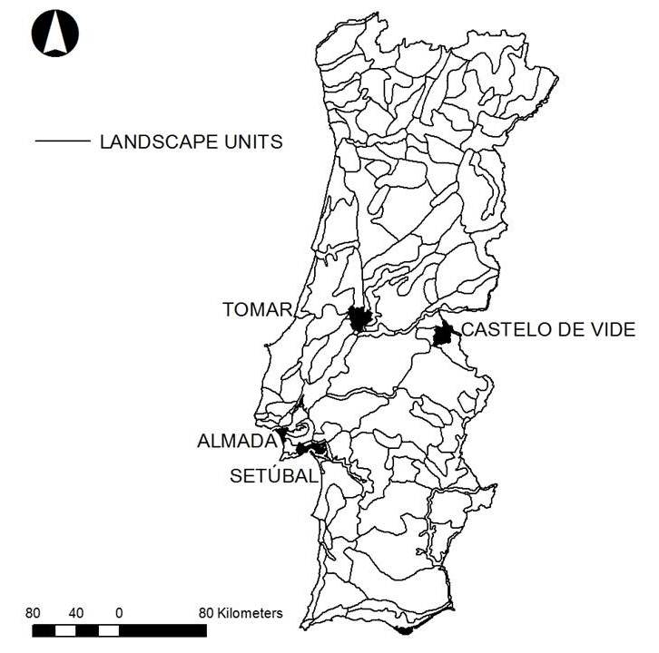
Fig. 4. Geographic distribution of the case study areas in relation to the nation-wide LCA map (retirar Tomar – incluir lisboa e vila franca de Xira).

Mapping LCA at local scale has to our knowledge been carried out in different ways. Looking at recent work in the Lisbon Metropolitan Area, it seems that landscape it still understood as a biophysical unit – isolating landscape for instance based on land cover as which can be called (as in the example of the recently published MMP of Vila Franca Municipality, just to mention one) – “Agriculture area”, “Uncultivated area”, ”Mediterranean forests and scrubs” or on land form, as “Valley area”. These generic names reveal a preference to refer to Landscape Character Types (LCT) rather than landscape character areas (LCA). Hence, the local scale is more suited for a finer grain analysis description of the landscape more generic types seem to be more straightforward to integrate in the local land use zoning plan (MMP) associated to specific regulation. There is a wide spectrum of methodological approaches to landscape classification and mapping (Van Eetvelde and Antrop, 2009). The 2011 guide to integration of landscape in local plans (MMP) suggests methodological approaches similar to those used in the nation-wide map, which is not surprising, as the leading author is the same (Abreu et al. 2004; Abreu et al. 2011). As local administrations may chose not to use the guide, it may be speculated if this LCA approach is indeed suitable to support decision-making at local scale.

In the selected case studies - presented here in this section - we challenged this hypothesis by intentionally using a similar holistic methodological approach as it was used to define the national-wide LCA map. A stepwise approach was adopted and adapted to the specific nature of each case study area and the institutional arrangement with each local administration: collecting of geographical information of the municipally; overlaying of LCA identified in the nation-wide scale present in the area of the municipality; mapping of the 1st draft of LCA based on exploratory overlay of thematic maps (biophysical and socio-economic) and use of aereal photographs; identifying perceptual dominance of character elements on field work in expert groups based on the ECOVAST landscape matrix (2006); mapping the 2nd draft of LCA based structured overlays of selected thematic maps resulting from the previous step – focus on identification of boundaries; characterizing of LCA and naming within the expert group; surveying the local public using the 2nd draft; and finally, mapping of the final LCA map through the integration of contributions of local public and refinement of boundaries and names.

The social and perceptive dimensions are most often left out of large scale LCA (Groom 2005, Swanwick 2009). When working at local scale other sources of information become available, which make it possible to explore these dimensions. In the process of LCA mapping local knowledge bases are relevant to get insight on how landscape “elements come together to create character in different places, including the aesthetic and perceptual qualities of the landscape as a whole” (Swanwick 2009:579). Existing literature on landscape perception is wide and there is also a wide array of methodological toolboxes on how to capture perceptive dimensions of the landscape, in large part based on public surveys to specific landscapes (e.g., Tveit 2009; Fry et al. 2009; Fagerholm and Käyhkö 2009). Despite report on an array of practical examples used in England and Scotland (Swanwick - topic paper 3), these approaches have proven difficult to operationalize in the allover framework of the planning process, notably in Portugal. Based on a recent review of how landscape was used in all MMP approved after 2000, we can conclude that LCA is - more often than not - carried out in parallel to the planning process and only integrated in the characterization stage. Even though to our knowledge there is no recent Europe-wide overview of these processes, discussions held in international conference and workshops, this is also the case in many other countries and regions.
The case studies presented here are examples of parallel studies, developed in academic context. At some stage these studies touched ground with the ongoing planning process, notably in the cases where session with local administrations took place. It is not straightforward to identify who the public of a landscape is (Loupa-Ramos 2011). Swanwick (topic paper 3) suggests a division into 2 groups: “communities of interest” (local administration or NGO) and “communities of place” (residents or visitors). In case studies of Castelo de Vide the “community of place” was addressed using a public survey and in the cases of Almada and Setúbal the “community of interest” was involved through focus group meetings within the local administration (decision-makers and technical staff).

Public surveys in Castelo de Vide
In the municipally of Castelo de Vide the local public was surveyed concerning their landscape perceptions. A public survey was designed in order to understand whether the expert’s judgment was in consonance with the public perception of what was determinant of landscape character in this municipality (Menezes 2007). The LCA draft map was the basis for this survey. Concerning the survey design six photographs were taken, each representative of the landscape character areas and sub-areas identified (Fig. 5).

(A) | (B2)
(B1) | (C1)
(B3) | (C2)

Fig. 5. Representative images of each LCA in the draft map of Castelo de Vide – see fig. 7 – map in the center.

Printed photographs were shown to people met in public place in the area of municipality. These had been previously edited in the sense of homogenizing sky and light conditions, in order to facilitate the focus on the landscape itself.
The first two questions in the questionnaire aimed to establish a baseline. They aimed to understand whether the public would locate the photos within the area of the municipality: Question 1 - Do you recognize the places on the photographs?; and Question 2 - Can you locate, more or less, these place within the municipality?.
Question 3 aimed to understand to which extent the public would identify the photos according to the areas on the 2nd LCA draft map: “Can you group the photographs according to what you feel more similar?. Facing all photographs the responded could create as many groups of photographs they wished based on the similarity they observed. The survey was randomly applied to the population of Castelo de Vide municipality (n=30). The surveys were analyzed by comparing the recording frequency on which people grouped and differentiated the 6 photographs from 2nd draft map (Fig. 6). The upper graph shows the way in which respondents grouped the photographs from the 2nd draft map and the graph below shows the frequency in which each photograph was attributed to the corresponding LCA on the draft map with one photo only.

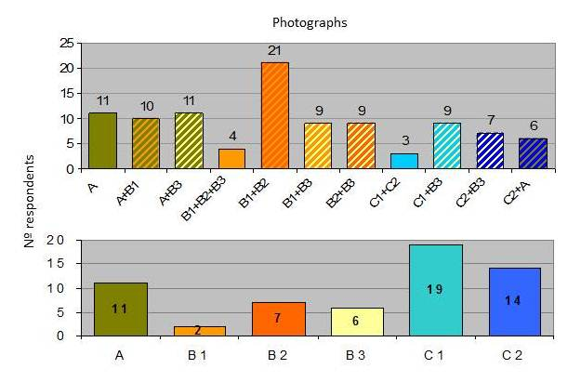
Fig. 6. Frequency of groups of photos (on top) and isolated photographs attributed to each LCA area (below).

Results provided information for reviewing the draft map. The respondents were clearly able to recognize very well some LCAs, as ‘A’. This LCA is strongly based on its geological and lithological characteristics and with strong influence in the land cover. It is a sharp and contrasted boundary present already in the 1:250,000 nation-wide LCA map (see Fig. 7 to the left).
Others were not that that clear to the respondents. While the expert group did put emphasis on differencing degrees of openness of the “montado”, the respondents did not differentiate these areas at all (B1, B2 and B3), viewing them rather as variations of the same pattern – an agro-silvo-pastoral system with differentiation according to rock outcrops, shrubs, black-oak and open areas.
Also where the experts perceived relief as dominant character element joining the urban area and surrounding olive grove mosaic with the mixed forest, based on elevation data, the respondents did not perceive the same. For them the most dominant feature differentiating landscape character was degree of human presence. Therefore they strongly perceived the village and surrounding olive groves as one LCA and the dense mixed forest as a completely different one.
As Fig. 7 (to the right) shows, the main result is the final landscape character areas with the public integration, for the Castelo de Vide municipality, where the ‘Agro-Silvo-Pastoral landscape area’ (B) was simplified and aggregated into one landscape unit; and the ‘Olive Grove Mosaic landscape area’ (C) and the ‘S. Mamede Hills landscape area’ (D) were divided into two completely differentiated units.

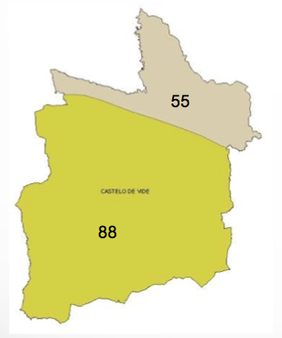 | 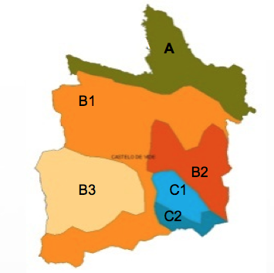 | 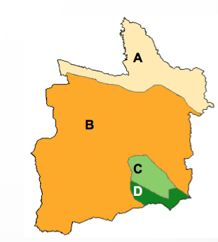
55 – Terras de Nisa  88 – Serra de S. Mamede | A – Peripheral landscape with shrubs and forest  B1 – Agro-silvo-pastoral landscape  B2 – Agro-silvo-pastoral landscape with high density of rock outcrops  B3 – Agro-silvo-pastoral landscape with open farmed areas  C1 – Valley with diversified mosaic  C2 – Hills with forest and shrubs | A - Schist  B – Agro-silvo-pastoral  C – Living Mosaic  D – S. Mamede Hills

Fig. 7. Simple overlay of the 1:250,000 nation-wide LCA maps on the administrative limits (to the left); draft map (on the center) and final map (to the right) incorporating by the simplification of the “B” area and the individualization of both “C1” and “C2” areas.

Focus Groups in Almada and Setúbal
In the case of Almada four groups engaged separately into the discussion on their perceptions on the draft of the LCA map for the municipality: the technical staff of the urban planning department (7), elected (political) representatives of the municipality executive (6), technical staff of the environmental department (4); and the technical staff of the urban management department (23). The main inputs of these groups to the final map were related the usefulness of LCA for urban and environmental planning. Thus some landscape areas were considered for redefinition. Landscape area “F” (Fig. 8, to the left) was sub-divided into F1 and F2 (Fig. 8, to the right, colored in shades of blue) having planning objectives in mind. Thus, two areas were isolated, as F2 that was found to relate to the Atlantic coast mainly on sensorial grounds - smell, sound - and therefore should be management for tourism activities primarily. F1 was found to be less affected by the Ocean and therefore its management would be better suited for residential uses.

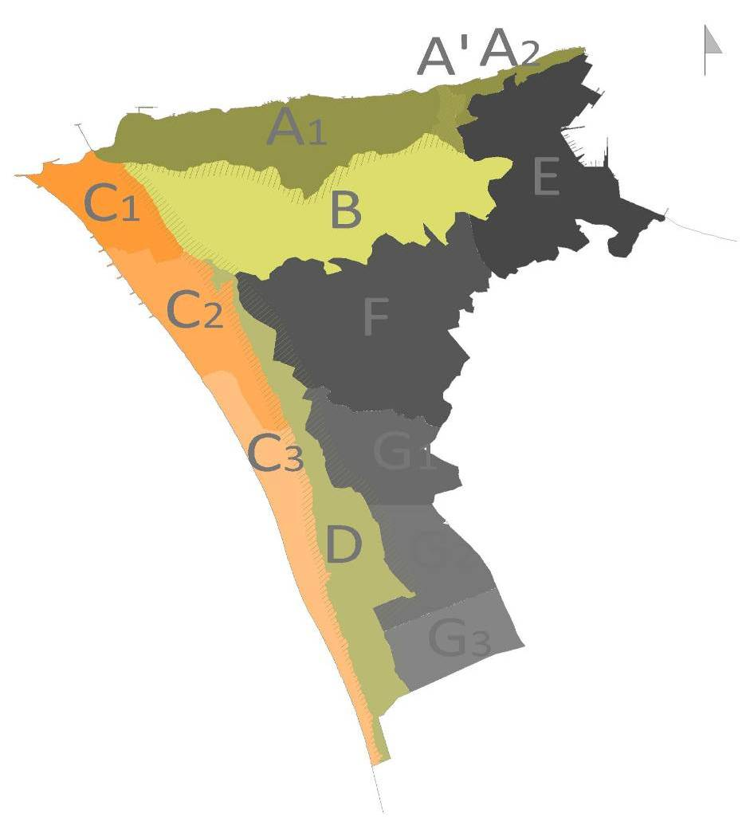
Fig. 8. Integration of results of contributions of focus groups to the final LCA map in Almada (to the right) based on the 2nd draft map (to the left).

The meeting with the technical staff from the urban management department yielded unexpected results. The main function of this department is enforcing the rules defined in the urban plans that are defined for each urban management unit (UMU). Typically these UMU are limited using existing roads. Meaning, that on one side of road one set of rules applies, and another set on the other side of same road. The staff stated that is sometimes difficult to communicate to the communities “why the rules change if it all looks the same”. They found that defining UMU based on LCA that were clearly perceivable different by people would enhance communication between the population and the public administration.

In Setúbal only one meeting took place. The group was formed (35) by participants who responded to a call send out by mail to all municipal bodies. To make this meeting more operational four draft maps were shown carried out with the same methodology but by different expert groups. This made a comparative discussion possible where the participants verbalized what they thought would better accommodate their own perceptions.

Fig. 9. LCA mapping in Setúbal : Map1 (up left); map 2 (up right); map 3 (down left); and map 4 (down right).

Even though all maps show the same set of main units (Northern sandy plain of Azeitão, the Arrábida mountains and valleys, the city of Setúbal in the center, and to the east, the industrial peninsula of Mitrena, the remaining “montado” areas and the marshlands), the boundaries differ substantially. The East/West division is also well defined in the nation-wide LCA map (fig. 1) based foremost on urbanization patterns and landform – dividing Landscape Group “N” from Group “Q” of the Sado Valley.

After the discussion with the local administration the preferred LCA map - in the sense of what they felt to me more useful in their work - turned out to be the map 1. It was found to be more clear and “manageable”. It is the map that most strongly builds on land use and that is clearly recognizable by the local administration finding a high correspondence to their own municipal zoning map. In the discussion this became very clear at the urban boundaries. Map 1 generated most consensus because it limited the urban landscape by the density urban pattern (D) – identifying the rest as agriculture (G). Other maps aiming at expressing that transition at the urban fringe determined the character of that landscape turned out to be too “fuzzy” and difficult for the local administrations to incorporate into the urban management process. This experience fits clearly into the urban/rural divide that still shapes the present planning paradigm and the mind-set of planners. In this context it becomes understandable why local administrations give preference to Landscape Character Types (LCT) approaches rather than a more holistic and comprehensive LCA approaches – as discussed at the beginning of this section, using Vila Franca de Xira as an example.

As mentioned before, the concept of scale is multifaceted. Dealing with scale is also about dealing with power relationships and hierarchy. In the case of Castelo de Vide clearly the perception of the “community of place” was a of scale of hierarchy, making explicit what was more relevant to them and to the sense of belonging to that landscape, by valuing aspects that relate to their identity. Whereas in the cases of Almada and Setúbal the contribution of the “community of interest” was a demonstration of the scale of power relationship – “what we allow or restrict to do where”. When dealing with size and detail the nation-wide LCA map is difficult to use at local scale. The overlaying procedure of the 1.250,000 maps on the 1:25,000 yields a better response in rural and nature-dominated landscapes than in more urbanized ones. In the first case this procedure is found useful because it set a basis to start to subdividing bigger units and giving more accuracy to the boundaries based on the use of more detailed geographic information (as in the case of Castelo de Vide – see Fig. 7). In the latter case, as in Setúbal, but even more in Almada, this process was not found to be suitable, mainly because the factors that were perceived by the experts to differentiate the character at 1:250,000 scale seem not to be the same at 1:25,000. Here other factors gain more relevance, as for instance, urban morphology, color and style of architecture, or the relationship between the green and build-up areas.

- Progressing across scales
To our knowledge the national and regional scales are being tackled rather well in Portugal and elsewhere. The local scale, depending on what “local” means in each context and what is the specific purpose of the LCA mapping, calls for adaptations and for the development of methodological approaches that are best suited to integrate local knowledge bases.
The ELC is applicable to all Europe and should contribute to the “consolidation of the European identity” and it also applies “to the entire territory of the Parties and covers natural, rural, urban and periurban areas”. With this backdrop on mind, it would be expected to find a European-wide consolidated map, as well as, a wide range of experiences at urban scale. As ELC is focused on the “well-being of citizens” – urban and periurban area are the everyday landscape to the majority of the European population. Nevertheless these two scales – European and urban - are still lagging behind. In this section we would like to reflect on “if” and “how” to progress with LCA mapping towards a more detailed urban scale and to a more generalized European scale.

4.1 The urban challenge
LCA mapping is less frequent in urban landscapes. Despite a wide range of professionals and disciplines engaging in the urban landscape (Loupa-Ramos and Silva 2015). This rises the question if the landscape is not already “taken care of” using other conceptual and methodological approaches. As mentioned in section 3 for more urbanized municipalities, methodologies that have been developed specifically for rural landscapes and cannot be directly transferred or downscaled to urban landscapes.
Urban landscapes have been approached from a landscape ecology perspective. This perspective despite acknowledging that urban landscapes comprise both built and unbuilt land in a complex mosaic tends to focus on the natural elements of the urban landscape and its vast range of ecological and social functions, or the interaction between these (e.g. Sukopp and Wittig 1993; Alberti, 2008; Niemela, 2011; Marzluff, 2008). This has set the basis for an urban ecosystem service approach that aims at assessing its value (e.g. Haase et al., 2014, Gómez-Baggethun and Barton 2013) but also for the analysis or structural aspects as embedded in landscape metrics (e.g. Leitão et al. 2006). From an urban studies perspective, urban landscapes have been addressed in two ways. One way has been to place the emphasis specifically on open and public space (e.g. Cullen, 1971; Maciocco, 2008), and a second grounded in urban morphology (e.g. Jabareen, 2006) – a pattern resulting from the aggregations of repeating elements in multiple layers as land use patterns, transportation or open space has also benefited from tools such as space syntax to express the structures of the city (e.g. Ratti 2004).

Surprisingly, or not, between the 60ties and the 80ties Kevin Lynch and Richard Forman approached space by using 3 key elements – points, lines and areas. Lynchian elements are paths and edges (linear), districts (areas), nodes and landmarks (points). Forman proposes the matrix (areas), corridors (linear) and patches (points or areas depending on the scale) and where also the edge (linear) came to play a pivotal role.
Even though the set of key elements almost coincide, Lynch uses those elements in a qualitative way to explore the identity of urban spaces and how people use them in their mental maps, whereas Forman and followers used this model for quantitative approaches leading to landscape metrics in natural landscapes (notably in the American school of landscape ecology). About the same time CAD/GIS technology is in its early stages, and besides the raster data model, the object model (i.e. vector model) is put forward describing the world in – points, areas and lines (Aronoff, 1989; Goodchild, xxxx).

This very brief historical overview makes us eventually think that multiple disciplinary backgrounds use the same conceptual models and technological framework to read the landscape. Meaning that eventually what hampers the unification of approaches in a holistic way is that we are looking at different “things” in the same landscape valuing them differently – looking at the built vs. natural features, or looking at humans vs. other species. Still to some scholars, towns and landscape are still an “empty set” and mutually exclusive. In Portugal there is even a popular proverb for expressing this idea – “Lisbon is Lisbon, and the rest is landscape”.

An exercise carried out in the city of Lisbon with a multidisciplinary group in academic context (see Loupa-Ramos and Silva 2015 for details) showed the limits of applicability of traditional LCA mapping approaches as those described in section 3. But is also shows the opportunities to go deeper in exploring the landscape identity concept (Loupa-Ramos et al. 2015) into LCA mapping – integrating landscape into urban planning is also about dealing with communities and neighbourhoods (Healy, 2005) in improving citizen well-being.

4.2 Towards a European map?
At a totally different scale, the national classifications of the landscape character differentiation can eventually also be used to inspire and validate higher level classifications, at the European scale. There are many possible classifications of the European territory, which stand close to a classification of its landscape character. Examples are the environmental and biophysical classifications of Europe produced with existing data sources at detailed scales and advanced spatial analysis (Hazeu et al 2011; Metzger et al 2005). But these are nevertheless not landscape classifications; as the character can hardly be grasped by automate analysis and georeferenced information. The existing and widely recognized classification is the one produced by Meeus in the early nineties, further reproduced in the Dobris Assessment. But still this is a strict expert based map, which has been much criticized due to the lack of consistency – for instance due more detail in areas he knew better. For the production of a new landscape character map of Europe, combined approaches would be required: advanced spatial analysis of existing data sources grounded on scientific evidence, to secure consistency and data quality; and, in order to enhance the legitimacy of the map, specification of units boundaries and of the landscape character supported in the various national classifications. So far such a map is not produced, and therefore the upscaling of the national landscape character areas is still an open issue, even though to us, a European map does not seem viable as a patchwork of national maps only. Taking advantage of available technology to analyze big data sets together with broad participation of experts at multiple scales in a combined bottom-up/top-down approach, seem to us to create a possible way towards a consensual map that can set the basis for European Identity and for a more targeted European policy making.

5. Conclusion
In this chapter we have outlined how landscape has been integrated into Portuguese legislation. We have shown how the landscape character map of Portugal has been developed and used so far, at different scales and for different planning exercises. We have also seen how these different uses have raised questions and not always providing a clear role for the landscape character mapping at various levels of decision. But nevertheless, the uses described show there is a growing recognition of the need to consider the landscape and its overall character, both in the general spatial planning and in the sectorial strategies.
We mean by this that the landscape character may not be pushed forward as it would be desirable, from the perspective of those who work with the landscape. But advances have been made and the landscape is nowadays one topic more on the agenda of those dealing with the territory, than it was some years ago. The future is uncertain though, mainly due to the clear lack of landscape perspective in most sectorial activities that in fact construct or damage the landscape, like agriculture, tourism or infrastructures.
LCA mapping shows high potential as a tool for communication amongst different perspectives and scales. It is ultimately a “mental device by which we categorize and make sense of the world” (Herod 2011: xi-xii), and which happens to be pivotal in how we - as a society- chose shape our future landscape.

References
Abreu A., Botelho M.J., Oliveira R., Afonso M., A paisagem na revisão dos PDM - orientações para a implementação da Convenção Europeia da Paisagem no âmbito municipal, DGOTDU, 2011.
Abreu A., Pinto-Correia T. Oliveira, R., Contributos para a Identificação e Caracterização da Paisagem em Portugal Continental, Colecção Estudos 10, DGOTDU, 2004.
ALBERTI M. (2008), Advances in Urban Ecology: Integrating Humans and Ecological Processes in Urban Ecossystems, New York, Springer.
ALBUQUERQUE, J.P.M., 1954. Carta ecológica de Portugal. Ministério da Economia, Direcção Geral dos Serviços Agrícolas, Repartição de Estudos, Informação e Propaganda. Lisboa, 58 pp.
Aronoff S., 1989. Geographic Inform ation Systems: A Management Perspective. WDL Publ., Ottawa, Canada
Council of Europe, European landscape convention, ETS176,2000.www.coe.int/t/dg4/cultureheritage/heritage/landscape/default_en.asp. Accessed 1 February 2012.
CULLEN G. (1971), The Concise Townscape, New York, Architectural Press.
Eetvelde V., Antrop M., A stepwise multi-scaled landscape typology and characterisation for trans-regional integration, applied on the federal state of Belgium, Landscape and Urban Planning, Vol. 91, 2009, pp.160–170.
European Council for the village and small town – ECOVAST, Landscape identification – A guide for good practice, 2006.
Fagerholm, N. and Käyhkö, N. (2009). Participatory mapping and geographical patterns of the social landscape values of rural communities in Zanzibar, Tanzania. FENNIA 187, 1:43-60.
Ferreira A.G., Gonçalves A.C. and Dias S., 2008. Desenvolvimento de uma Abordagem para a Definição de Funcionalidades a Privilegiar por Zona Homogénea. Silva Lusitana, nº especial: 69 – 77.
FORMAN R. and GODRON M. (1986), Landscape Ecology, Minnesota, Wiley.
Gómez-Baggethun E. and Barton D. (2013) Classifying and valuing ecosystem services for urban planning. Ecological Economics 86: 235–245.
GROOM G. (2005), “Landscape Character Assessment around Europe”, in: Pérez-Soba M. & WASCHER, D.M. (eds), (2005). Landscape Character Areas. Places for building a sustainable Europe, Policy Brochure as deliverable from the EU’s Accompanying Measure project European Landscape Character Assessment Initiative (ELCAI), funded under the 5th Framework Programme on Energy, Environment and Sustainable Development (4.2.2), pp. 33.
Groom G., Landscape Character Assessment around Europe, In: Wascher (Eds), European Landscape Character Areas - Typologies, Cartography and Indicators for the Assessment of Sustainable Landscapes, Alterra Report No. 1254, Landscape Europe, 2005, pp.32-45.
HAASE D., FRANTZESKAKI N. & ELMQVIST T. (2014), “Ecosystem Services in Urban Landscapes: Practical Applications and Governance Implications”, AMBIO, 43, 4, Springer, pp. 407-412
Hazeu G, Metzger M, Mücher C, Perez-Soba M, Renetzeder C, Andersen E (2011) European environmental stratifications and typologies: an overview. Agriculture, ecosystems & environment 142(1):29-39
Healey P. Collaborative Planning: Shaping Places in Fragmented Societies. Palgrave Macmillan, 2006.
JABAREEN Y. (2006), “Sustainable urban forms – their typologies, models and concepts”, Journal of Planning Education and Research, 26, pp. 38-52.
LEITÃO A.B., MILLER J., AHERN J. & MCGARIGAL K. (2006), Measuring Landscapes – A planner’s handbook, Washington, Islands Press.
Loupa-Ramos I., Landscape Quality Objectives' for remote rural landscapes: experts' and stakeholders' perspectives towards future developments. In: The European Landscape Convention: Challenges of Participation. Jones and Stenseke (Eds), Springer Landscape Series. 2011, pp. 199-218.
LYNCH K. the image of the city.
MACIOCCO G. (2008), Urban and Landscape Perspectives: Volume 2, New York, Springer.
MARZLUFF J. (2008), Urban Ecology: An International Perspective on the Interaction Between Humans and Nature, New York, Springer.
Menezes H. Integração dos agentes locais na definição e caracterização de unidades de paisagem. Caso de estudo: Concelho de Castelo de Vide, Trabalho final da licenciatura em Arquitectura Paisagista, Universidade de Évora, 2007.
Metzger MJ, Bunce RGH, Jongman RHG, Mücher CA, Watkins JW (2005) A climatic stratification of the environment of Europe. Global Ecology and Biogeography 14(6):549-563
NIEMELA J. (2011), Urban Ecology: pattern, processes and applications, Oxford, Oxford University Press.
Pinto-Correia T. and Godinho S. , 2013. Changing agriculture – changing landscape: what is going on in the high valued Montado landscapes of Southern Portugal ? In:Ortiz-Miranda, D., Moragues-Faus, A.M., Arnalte-Alegre, E. (eds), Agriculture in Mediterranean Europe Between old and new paradigms. Research in Rural Sociology and Development, vol. 19, Emerald, pp.75-90
Pinto-Correia T. and Primdahl J., 2009. When rural landscapes change functionality: constraints and development options for multifunctional landscapes. Examples from contrasting case-studies in Portugal and Denmark. In: Brouwer F. and van der Heide M. (eds), Multifunctional Rural Land Management: Economics and Policies, Earthscan: 213-234
Pinto-Correia T., 2010. Assessing the Future Role of Agriculture in Peripheral Rural Landscapes. Application to Portugal In: Primdahl J. and Swaffield S. (Eds.), Globalization and Agricultural Landscapes. Change Patterns and Policy Trends in Developed Countries, CUP, Cambridge: 127-148
Pinto-Correia T., Cancela d’Abreu A. and Oliveira R., 2003, Landscape Units in Portugal and the development and application of Landscape Indicators. In. Dramstad W. and Sogge C. (Eds.), Agricultural Impacts on Landscapes. Developing Indicators for Policy Analysis. NIJOS / OECD, NIJOS 7/2003, Oslo, pp.309-318
RATTI C. (2004), “Urban texture and space syntax: some inconsistencies”, Environment and Planning B: Planning and Design, 31.
Ribeiro, O. (1987) Portugal: O Mediterrâneo e o Atlântico. Livraria Sá da Cista Editora. Colecção Nova Unversidade. Lisboa.
Stanners D, Bordeaux P (eds) (1995) Europe's Environment; The Dobříš Assessment. European Environmental Agency, Copenhagen.
SUKOPP H. & WITTIG R. (1993), Stadtoekologie:Ein Fachbuch fuer Studium und Praxis, Stuttgart, Gustav Fisher Verlag.
Swanwick (topic paper 3)
Swanwick C., Landscape Character Assessment (Guidance for England and Scotland) – Recent practice and the evolution of Landscape Assessment (Topic Paper I), Scottish Natural Heritage and The Countryside Agency, 2002.
VAN EETVELDE V. & ANTROP M. (2009), “A stepwise multi-scaled landscape typology and characterization for trans-regional integration, applied on the federal state of Belgium”, Landscape and Urban Planning, 91, pp. 160-170.
Wascher D., Landscape character: linking space and function, In: Wascher (Eds), European Landscape Character Areas - Typologies, Cartography and Indicators for the Assessment of Sustainable Landscapes, Alterra Report No. 1254, Landscape Europe, 2005, pp.1-4.

Acknowledgements: the authors would like to thank all students enrolled in the course of Landscape Ecology at IST (University of Lisbon) in the academic years of 2007/2008, 2011/2012, 2013/2014, as well as Helena Menezes who worked in Castelo de Vide for her Master Thesis in Landscape Architecture (University of Évora); Sara Dias from ISA (University of Lisbon) who helped during her internship at the municipality of Almada; Ricardo Silva who assisted the students in the academic year of 2013/2014 at IST; Filipa Monteiro who worked on the survey of the landscape in MMP that was presented at UBL Landscape conference in Brussels 2014; Nuno Guiomar who helped in the production of the maps; and last but not least, all the people that took part in the public surveys and focus groups.

