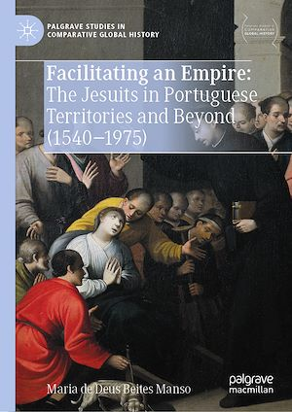

This book explores the Jesuit order of its origins, historical evolution, missionary endeavors, and global dynamics, with a specific focus on Portugal and the challenges arising from changes in the former Portuguese Empire. The narrative unfolds in three parts, with the initial section exploring the foundation of the Jesuit order in 1540, approved by Pope Paul III. Examining the order's presence in Portugal, its connections with the Portuguese monarchy, and its educational initiatives, the exploration extends to a global Christianization mission aligned with crown and Roman interests.  The second part shifts focus to Jesuit provinces beyond Europe, exploring regions with limited European presence through missionary action. Using a comparative and connected historical approach, the study analyzes missionary geography, identifying parallels and differences shaped by a "collective" dynamic involving the Society of Jesus, the crown, Rome, and diverse geographical dimensions. The third segment addresses the restoration of the Society of Jesus, particularly in Portugal, navigating global dynamics. The evolving landscape of the former Portuguese Empire necessitates a new contextualization, signifying the need for currently unfeasible investigations. The book will appeal for an academic audience with a specific interest in the detailed examination of the Jesuit order's history, its organizational structure, and its impact on missionary activities, both within Portugal and in regions with limited European presence.