The value and potential of a ‘landscape-systems’ approach to agroforestry: insights from an Iberian context
Muñoz-Rojas, J., Pinto-Correia, T., Guiomar, N., Ravera, F., Surova, D., Guimarães, H., Godinho, S., Margarida Fonseca, A., Azeda, C. and Fonseca, C.

Instituto de Ciências Agrárias e Ambientais Mediterrânicas -Universidade de Évora (Portugal). Núcleo da Mitra. Apartado 94, 7000-554, Évora, Portugal Tel: 00-351-266760885 (ext. 24610) jmrojas@uevora.pt

Abstract: Agroforestry land uses are widely acknowledged to be complex social-ecological systems, and are strongly valued for their multi-functionality and capacity to deliver multiple ecosystem services. In the Western Iberian context, open forests dominated by various species of oaks and supporting various mixtures of agricultural, forestry and pastoral practices are clustered under the terms of ‘dehesas’ in Spain and ‘montados’ in Portugal. These have recently been considered as exemplary land-use systems in which sustainability and resilience are enhanced by multiple interactions among their socio-cultural, economic and biophysical sub-systems. Regardless of the acknowledgement of the complexity that characterizes dehesas and montados, to date most of the scientific approaches to study them have been disciplinary or at times interdisciplinary, and only recently transdisciplinary approaches have been proposed. Furthermore, we consider that a number of the self-claimed transdisciplinary approaches to study montados and dehesas have been rather passive. In response to this, in the DYNAMO Research Group at the University of Évora (Portugal) we propose a (continuous) process of framing research on complex dehesa and montado systems based on what we generically term as a ‘landscape-systems’ approach. Our understanding of a ‘landscape-systems’ approach is firstly aimed at jointly embedding the multiple dimensions (biophysical, socio-economic and perceptive or cultural) and cross-scale interactions of land-use systems that emerge when they are considered as landscapes. This would permit breaking the boundaries that exist between scientific disciplines and also between such disciplines and the multiple spheres and scalar levels of land-use governance and practice. Additionally our proposal of a ‘landscape-systems’ approach is ultimately aimed at ‘to support the implementation of an action-focused research program for dehesas and montados. This would be characterized by a full-life-cycle action schedule which can only be built in continuous and long-term interaction with stakeholders and other members of the wider citizenship, and where gaining mutual trust is key to success. We believe that this is an approach that could be explored in other agroforestry systems across Europe, especially those encountering barriers in translating research into practice and action.

Keywords: agroforestry, montados, dehesas, systems science, landscape systems, action-oriented research

Introduction

1.1 Justification, objectives and structure of the study
Agroforestry land uses are widely acknowledged to be complex social-ecological systems, and are strongly valued for their multi-functionality and capacity to deliver multiple ecosystem services (Jose, 2009; Power, 2010). Actually, the potential efficiency of agroforestry in delivering multiple benefits to human well-being has been acknowledged for some time (Spurgeon, 1979). In the Western Iberian context, open forests dominated by various species of oaks and support various mixtures of forestry, pastoral and at times arable practices are clustered under the terms of ‘dehesas’ in Spain and ‘montados’ in Portugal. These are considered as exemplary land-use systems in which sustainability and resilience are enhanced by the multiple cross-scale interactions among their socio-cultural, economic and bio-physical sub-systems, with new properties emerging at different scales of outcomes and complex feedback loops between such interactions (Bugalho et al, 2011; Pinto-Correia, Ribeiro and Sa-Sousa, 2011; Sa-Sousa, 2014). Consequently one could argue that the principle that the ‘sum is more than the parts’ which forms the basis of systemic thinking is inherent to these land-use systems and related landscapes.

Regardless of the acknowledgement of the complexity that characterizes montados, to date most of the scientific approaches to study them have been disciplinary or at times interdisciplinary, and only recently transdisciplinary approaches have been proposed (Ferraz de Oliveira, Azeda and Pinto-Correia, 2016). Furthermore, we consider that a significant proportion of the self-claimed transdisciplinary approaches to study montados (and similarly to dehesas in the Spanish context) have been rather passive (McKee, Guimaraes and Pinto-Correia, 2015). In response to this, in the DYNAMO research group at the University of Évora (Portugal) we propose a (continuous) process for framing research on complex Montado Systems based on what we generically term as a ‘landscape-systems’ approach.

The objective of this paper is therefore to discuss the advantages and potentialities of such approach to contribute to the management and planning of sustainable and resilient agroforestry systems, models and practices, exemplified in this case by the Portuguese montado.

The paper begins by introducing the main characteristics of the montado in its consideration as a traditional agroforestry system that is currently endangered by socio-cultural, economic and biophysical changes. Later on we describe the research rationale and approach tested, which begins by both analyzing and interpreting the current social-ecological trends and challenges of any agroforestry system when it is considered from a landscape-systems perspective. The same section describes how the rationale and approach applied is necessarily underpinned by a long-term, continuous and bilateral collaboration between scientists and a wide range of stakeholders that act across multiple sectors and scales and frequently represent diverging viewpoints and perspectives. We subsequently analyze the (preliminary) results obtained in our own case study area over the course of more than a decade of research. We then further reflect on the implications of such results for refining the proposed analytical approach in order to support more sustainable and resilient landscape management, planning and protection frameworks and regimes, both within and beyond our own case study. Finally, we sum up by highlighting the main advantages and risks that are associated with the proposed approach, and the steps that are required for it to become fully applicable in a wide variety of agroforestry systems.

Montados and dehesas of south west Iberia
The montados and dehesas of south west Iberia are Mediterranean silvopastoral land-use systems dominated by holm oaks (Quercus rotundifolia Lam., 1785) and cork oaks (Quercus suber Lam., 1785) covering a wide range of tree stand densities (Pinto-Correia, Ribeiro and Sa-Sousa, 2011; Sa-Sousa, 2014). They are recognized for their capacity to deliver a wide number and variety of ecosystem services. In addition, and due to their intrinsic nature as multi-functional land-use systems, they are considered as a land-use type which has the potential to enhance the resilience and sustainability of rural and regional landscapes (Pinto-Correia, Ribeiro and Sa-Sousa, 2011).

Despite the acknowledgement that the montado provides multiple values and services and that it is an exemplar traditional silvopastoral system with a long history of resilience and sustainability (Pinto-Correia, Ribeiro and Potes, 2013), and multiple economic (Fragoso et al, 2015), biophysical (Costa, Pereira and Madeira, 2009; Godinho et al, 2014; Guiomar et al, 2015) and governance attributes (Pinto-Correia, Ribeiro and Sa-Sousa, 2011; Pinto-Correia, Ribeiro and Potes, 2013) there are challenges. Furthermore, challenges of relevance at global to national scales, such as climate change and associated human vulnerability, and the recent financial crisis, which has hit Portugal especially hard, are relevant at the scale and regional setting at which our study will be conducted.

In response to such challenges several strategic initiatives for regional development (e.g. Regional Strategy for Smart Specialization in Alentejo of December 2014 and the Operational Program for the Alentejo Region 2014-2020) are in place in our selected case study area. In such strategies the montado and its multiple products, values and services are considered as key assets for achieving sustainability and resilience beyond electoral cycles.

According to the 6th National Forest Inventory (ICNF, 2013), the two main dominant tree species in the Montado are holm oak (Quercus rotundifolia Lam., 1785) and cork oak (Quercus suber Lam., 1785), which jointly occupied 34% (11% and 23% respectively) of the total forested surface in mainland Portugal in 2010. A slight decline in the area occupied by holm oaks and cork oaks between 1990 and 2010 was highlighted in the same inventory. A similar decline was detected at the regional level for Alentejo (NUTS II). This is the Portuguese region with the highest number and surface area occupied by trees such as oak (ICNF, 2013).

The drivers, significance and potential consequences of the current overall decaying trend in the Montado are widely covered in the scientific literature (Costa, Pereira and Madeira, 2009), and emphasize its ecological, economic and social relevance beyond the relative smoothness of the statistical data showing an overall decline that is constant in time.

Rationale and a systems approach to rural cultural landscapes
Our understanding of a ‘landscape-systems’ approach aims to integrate the biophysical, socio-economic, perceptive and cultural dimensions with the cross-scale interactions within land-use systems that emerge when these are considered as landscapes (Pedroli and Pinto-Correia, 2006). This would permit breaking the artificial boundaries that exist between scientific disciplines and also between such disciplines and the multiple spheres and scalar levels of land-use governance, planning and management that jointly drive future trends in landscape change (Pinto-Correia and Kristensen, 2013).

In addition, our proposal of a ‘landscape-systems’ approach is ultimately aimed at ‘going beyond public participation’ and into active citizen-led decision making (Muñoz-Rojas et al, 2015) and in this way support the implementation of an action-focused research program for agroforestry systems, including dehesas and montados. This needs to be characterized by a full-life-cycle action schedule which can only be built in continuous and long-term interaction with stakeholders and other members of the wider citizenship, and where gaining mutual trust is the main key to success.

To help operationalize our understanding of what a ‘landscape-systems’ approach might mean in practice we elaborated the working sequence that is synthesized in Figure 1. This figure encompasses the various elements (both structural or objective and perceived or subjective) of the landscape-system that need to be individually analyzed and subsequently integrated in order to consider the social-ecological systemic nature that is inherent in landscapes (Matthews and Selman, 2006). Figure 1 also indicates the various spatial and temporal scales, and associated levels, that need to be considered simultaneously to design any actions concerning the landscape (Satake, Rudel and Onuma, 2008). According to Pinto-Correia and Primdahl (2012) the demand for public goods, such as biodiversity and cultural landscape values, are associated with the landscape level whereas, in contrast, landscape management is performed at the farm level. It is therefore clear to us that this analysis is to be best synthesized at or below sub-regional and municipal level and above the farming level. As is shown in Figure 1, this is a level at which data and information gathered at farm and landscape scales can then be summed up to quantify the potential contribution of the Montado to achieving National and Regional targets set either by the National Government (e.g. Decree-Law 155/2004 of the 30th June on the Protection of Holm and Cork Oaks) or Internationally (e.g. CAP policy reform 2015; Natura 2000 Network).

Furthermore, the sources of information required for analysis are equally important. Given the diversity and scope of information required to describe a system as complex as a landscape, there is a need for qualitative and quantitative, spatially explicit and statistical, socially elicited and secondary information of both scientific and lay nature (see Figure 1). Last, it is eventually important to indicate how the collated information might ultimately inform the various landscape planning, management and protection actions within the European Landscape Convention (CE, 2000).

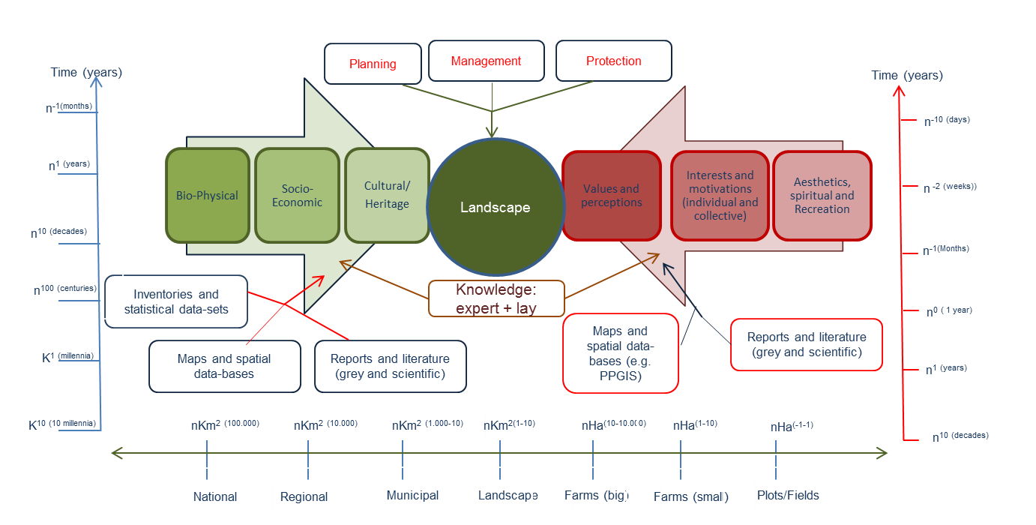
Figure 1. Elements, sources of information and scales,(both in time and space) and associated levels of analysis to be considered for implementing a landscape-systems approach to study agroforestry land-use systems. Scales to be jointly considered include a temporal one of relevance for social-political processes (red vertical), a further temporal one for biophysical processes and dynamics (blue vertical), and a spatial one of relevance for both aspects (horizontal scale).

One key aspect that arises when initiating such an approach is the enormous complexity of the challenge from both a conceptual and an operational perspective. This is despite the multiple and valuable attempts that are gradually arising to use landscape as a valid conceptual tool to bridge the gaps between natural and social sciences (Pinto-Correia and Kristensen, 2013), as an optimal scale for bridging public planning and private management of land and land-use (Pinto-Correia, Gustavsson and Pirnat, 2006) and as a critical asset for implementing transdisciplinarity (Mckee, Guimaraes and Pinto-Correia, 2015).

The complexity that is inherent in any landscape-based approach means that planning and managing land to achieve landscape change, sustainability, or resilience has been characterized as a ‘wicked’ problem, and thus partially intractable challenge (Duckett et al, 2016). The rationale and approach hereby tested is intended to contribute to addressing such wickedness, and it does so by proposing a working framework that must necessarily accomplish the following requisites: remain flexible enough to adapt to the inherent contingencies that pertain to the diverse geographical and socio-cultural contexts of potential application; incorporate as many scientific, social and professional paradigms, methods, techniques, tools, types of information and scales as potentially relevant with the ultimate goal to address landscape complexity; and engage with a wide a range of stakeholders that span beyond the traditional set of scientists, policy makers and land owners, and arrange with them the co-construction of knowledge over periods of time long enough to generate mutual trust, and favoring co-ownership of results over mere participation or collaboration.

Results and discussion

4.1 The Montado in Central Alentejo; structure and current dynamics
Following the reasoning elaborated in Sections 2 and 3 which underpins the development of our working approach and rationale, our study takes place at sub-regional level (NUTS III), in the area of Central Alentejo (Figure 2). Regions and sub-regions represent the institutional scales at which planning and policies are best placed to link together national targets for forestry, agricultural and livestock production, rural development and nature conservation with management and decision-making practices that are realized at the plot, farming and local levels (Pinto-Correia, Gustavsson and Pirnat, 2006; Carvalho Ribeiro, Madeira and Pinto-Correia, 2013). Furthermore, these are also the levels at which the basic guidelines and regulations for landscape planning, management and protection are actually delivered (CE, 2000).

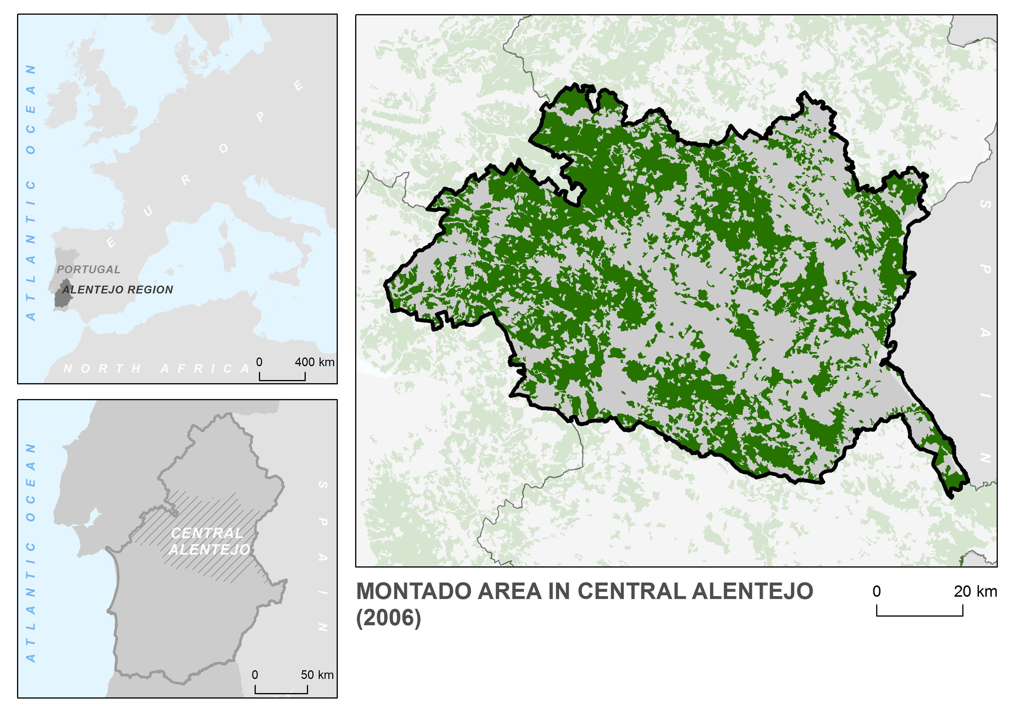
Figure 2. Location and distribution of the montado agroforestry system in the Central Alentejo region (Portugal).

In view of various technical problems encountered with the official definitions, delimitations and calculations of montados, we calculated the overall trends of change in the Montado of Central Alentejo between 1910, 1960, 1990 and 2006 using as baseline data those provided by Godinho et al (2014). This allowed us to move beyond the consideration made both in official inventories (ICNF, 2013), scientific literature (Costa, Pereira and Madeira, 2009) and even in the relevant legislation (Decreto-lei 55/2004 de ) of single tree species (holm oak and cork oak and into considering the montado as a land-use system of a multi-functional nature (Pinto-Correia, Ribeiro and Sa-Sousa, 2011; Sa Sousa, 2014), characterized by complex mosaic of spatial, ecological and landscape patterns (Pinto-Correia et al, 2011; Godinho et al, 2014). The results of this calculation for the Central Alentejo NUTS III Region are synthesized in Table 1.

According to data synthesized in Table 1, a key observation is the continuous decline after 1960 in the total surface covered by the Montado in Central Alentejo. However despite this, this land-use class still covers close to half of region in 2000-2010. In close alignment with data for changes in holm oaks and cork oaks in the 6th National Forestry Inventory (ICNF, 2013) the decline for the Montado in Central Alentejo can be considered relatively smooth. However, by looking at other relative statistical data comprised in Table 1 such as the variance and number of patches it is clear that a trend exists towards the progressive fragmentation of the Montado. This trend may bear important consequences of ecological, territorial, socio-cultural, economic and even aesthetic nature (Surova and Pinto-Correia, 2008; Pinto-Correia, Ribeiro and Potes, 2013; Godinho et al, 2014), which can affect human well-being and that therefore demand a landscape-systems approach.

It can be argued that the progressive loss and fragmentation of the Montado may result in negative effects on the capacity of landscapes in the region to deliver multiple ecosystem public goods and services, and consequently to achieve the strategic goals for regional sustainable development set by the public authorities.

Table 1. Evolution of the main absolute and relative spatial statistical indicators of the Montado Central Alentejo (1910 to 2006) according to baseline data by Godinho et al (2016).
 | 1910 | 1960 | 1990 | 2006
Total area (km²) | 3152.95 | 4030.35 | 3544.15 | 3466.77
Relative area (% Central Alentejo) | 43.60 | 55.81 | 49.16 | 47.68
Number of patches | 116 | 208 | 248 | 306
Mean patch size (km²) | 27.18 | 19.38 | 14.29 | 11.33
Variance (%) | 5.54 | 4.41 | 3.71 | 3.35
Maximum patch size (km²) | 1838.86 | 2496.06 | 2019.46 | 1987.46
Minimum patch size (hectares) | 0.33 | 0.93 | 0.41 | 0.27

The latest land-use and land-cover trends detected in the Montado of Central Alentejo highlight change that is not only quantitative but more importantly qualitative (Godinho et al, 2016). Along with the continuous spatial decline and landscape fragmentation, a further process of change of equal importance for the potential provision of multiple public goods and ecosystem services has risen over the past few years. This process is related to the structural change suffered by the Montado from a traditionally agro-silvo-pastoral system to a silvo-pastoral one, a change that is jointly driven by socio-demographic, economic, biophysical and even cultural changes in land-use practices and market dynamics (Godinho et al, 2014; Almeida et al, 2016).

Change such as those lately detected in the density, land-use and landscape heterogeneity and structural and ecological composition of the Montado in this region (Table 1) contribute to the important intensification/extensification debate (Pinto-Correia and Mascarenhas, 1999). This is ultimately also a valid argument to gain better understanding of the capacity for innovation in traditional and intrinsically complex and multi-functional land-use systems, such as agroforestry systems including the Portuguese Montado.

Key conflicts of use have been detected over the years between the Montado and several other land-uses. Some of the other land-uses with which the Montado conflicts include the Eucalyptus plantations that are aimed at the production of paper, medicines and soft-wood, and at the regulation flooding in plain areas, the expansion of extensive cereal and other herbaceous (e.g. maize) and ligneous (e.g. vines and olive trees) crops, and even in certain cases the abandonment of the underlying herbaceous layers of the Montado resulting in the progressive encroachment of the shrub vegetation strata (Godinho et al, 2014).

Such conflicts have all been considered of the upmost importance in diverse historic moments of the recent evolution of the Montado, and are reflected in the relevant legislation such as the already mentioned Regional Strategy for the Smart Specialization of the Alentejo (2014) and the Decreto-lei de 30 de Junho 155/2004 on the Protection of Holm and Cork Oaks. In this sense, it is also worth mentioning that the Montado is considered at European level as a High Nature Value farming system (Almeida et al, 2016; Paracchini et al, 2008), and thus object of special protection through tools such as Natura 2000 and the Habitats Directive. Despite this, between 2006 and 2012 (data from the CORINE Land Cover), about 1500 ha of Montado were substituted by olive groves in the Alentejo region alone.

The above diverse set of qualitative and quantitative changes since the mid-20th century have consequences and create challenges require a landscapes-systems approach. Furthermore, new societal demands value rural landscape functions related to sustainable resource management, landscape protection, leisure and recreation, (Pinto-Correia and Breman, 2009; Primdahl and Swaffield,2010). Last emerging forms of collective actions, slowly arising in the montados of Central Alentejo, also support a landscape approach. From a spatial ecological perspective, it is clear from our analyses that the current fragmentation and structural change of an ecosystem of high nature value (Habitat Directive), is posing challenges (e.g. enhancing ecological connectivity) that need to be addressed beyond the farm level.

This may have been positively influenced by the fact that an extensive network of Montado-based NATURA 2000 sites exists in our case study area, an initiative that is formally committed to contribute to the coordinated protection of this threatened and vulnerable land-use system. However, the transition towards a more effective multi-level governance model capable of supporting emerging forms of collective action is still only starting in the region, with issues such as the big size of private farms units and the small proportion of land under public or collective property potentially hampering alternative transition pathways.

4.2 Beyond ‘public participation’ and towards a co-construction of future landscapes
The management, planning and protection described in the European Landscape Convention (CE, 2000) requires an urgent move ‘beyond public participation’ (Muñoz-Rojas et al, 2015). A number of new tools, techniques and methods have been proposed and tested that might facilitate on-the-ground implementation of landscape-oriented strategies and actions by local stakeholders and other landscape users and beneficiaries. These tools are gradually moving away from printed spatial information as has been long employed in focus groups and participatory workshops for landscape planning, to the use of digital ICT tools that might support social learning, cooperation and innovation (Muñoz-Rojas et al, 2015). These tools include some aimed at use by experts (e.g. PPGIS) but others are useful for engaging social groups disenfranchised from planning and management, such as children (e.g. digital games).

We argue that a move towards more democratic and collaborative intervention regarding landscapes needs more than just sophisticated digital and ICT tools and techniques. Hence to address such complex challenges, the DYNAMO research group at the Universidade de Évora have decided to engage in a transdisciplinary process using the core idea stated by Klein et al. 2001, that is “different academic disciplines working jointly with practitioners to solve real-world challenges”. Such a process of engagement draws directly on the long-term experience with, and recognition that the Institute of Mediterranean Agricultural and Environmental Sciences (www.icaam.uevora.pt), of which the DYNAMO group is part, holds with key local and regional stakeholders (McKee, Guimaraes and Pinto-Correia, 2015). The distinctiveness on how such a collaborative research process his being held by our group, and its potential to integrate landscapes-systems perspective is synthesized in the following points:
- The wide range of sub-systems (social, economic, cultural, biophysical and perceptive), scales and actions jointly driving change in the complex Montado landscape-system have been all addressed within a single research institution (http://www.en.icaam.uevora.pt/sobre/missao). The research group recognises that the Montado is a unique agroforestry system which has a complex social-ecological nature. Whilst most outputs have focused on the Montado as a production system, outputs related to governance and social aspects are increasing.
- Furthermore, collaboration among researchers from different scientific disciplines and (sometimes conflicting) paradigms has been strongly encouraged, with more than 20 years of explicit research on the Montado system. The existence of a group such as DYNAMO, where social and natural, quantitative and qualitative, participatory and non-participatory, positivistic and post-positivistic approaches are embraced by individual members of the group (authors of this paper) within a shared landscapes-oriented approach, has proved key to implement truly interdisciplinary scientific approaches to the Montado.
- Along with the scientific and interdisciplinary construction of new knowledge, a long-term and continuous process of interaction with a vast range and number of local, regional and national stakeholders with relevance for the Montado in our case study area has been built over the past two decades. The continuity of such interaction has proved key in building confidence, trust and interest with groups of stakeholders that expands beyond the traditional set of farmers, land-managers and extension agents to include policy-makers and planners, consultants, financial agents, journalists, lobbyists with various and at times opposed interests, academics and researchers, conservationists, analysts, production chain agents and marketing professionals.
- Last, and of equal importance to the participation in multiple venues and events of scientific, professional and participatory nature, a direct engagement with the local communities, agents and authorities that in Central Alentejo have a stake in the Montado has been pursued by members of the group. This is essential to facilitate the implementation of a common research agenda and subsequent process of knowledge co-construction.

Conclusion and further steps forward
Based on the findings achieved so-far in our case study area of Central Alentejo, a series of conclusions could be drawn:
- The Montado is indeed a complex socio-ecological system. As such it cannot be managed, planned or protected for purposes of sustainability and resilience without jointly considering the multiple social, economic, biophysical, cultural and perceptual drivers, spatial-temporal scales and sets of stakeholders that intervene in its dynamics.
- The most recent trends in the Montado of Central Alentejo indicate to a decline in both its quantity and quality. The magnitude of such a decline is however not accurately documented in the official statistical and spatial information available. This is also true for the whole Portuguese Montado, and might also be the case for other agroforestry systems. Novel spatial and other ICT tools and methods of analysis are expected to improve documentation and facilitate realistic analysis of future sustainability and resilience.
- The aforementioned decline may have multiple negative social, economic and ecological consequences for the sustainability and resilience of the territories that have traditionally been, currently are and will potentially be occupied by montados. Consequently this trend will likely have negative impacts on the quality of the populations inhabiting those territories. Thus, halting this trend is both a public and a private responsibility, and therefore tackling it necessarily demands from a wider collaboration and knowledge co-construction between scientists, professionals, land-managers and wide range of other stakeholders.
- In this paper, we suggest that the ontological nature of landscapes as systems capable to encompass all of the socio-economic, ecological, cultural, biophysical and perceptual aspects of land and land-use render them as appropriate lenses through which to identify and implement innovations that enhance the Montado. Furthermore, agroforestry landscapes, such as the montado, provide a good “test case” for action-oriented research schedules that progress beyond public participation to the co-construction of knowledge and actions. Such potential rests mainly on the spatial-temporal scale and capacity for triggering mutual cooperation and sense of belonging that inherently defines any landscape approach.
- Despite of the relative favorable potential for action-oriented research in landscape-systems approaches to the montado agroforestry system by the DYNAMO research team at the University of Évora, numerous challenges remain. These include the necessity to critically revise and ground-truth the spatial and statistical datasets currently available, the requirement to refine and fine tune an operational framework that bridges together the structural and perceived components of landscapes, and the opening of our schedule to other scientists and technicians operating in the production-oriented (e.g. agriculture and forestry) aspects of the Montado in our case study area. An opportunity window for this is currently under course via a long-term schedule for knowledge co-construction among scientists and other stakeholders that we have termed as ‘Tertulias do Montado’. We expect that valuable lessons might be drawn from this process for other similar agroforestry systems worldwide.

References
Almeida, M., Guerra, C., Pinto-Correia, T. (2013). Unfolding relations between land cover and farm management: high nature value assessment in complex silvo-pastoral systems. Geografisk Tidskrifft-Danish Journal of Geography, 113(2): 97-108.
Almeida, M., Azeda, C., Guiomar, N., Pinto-Correia, T., (2016). The effects of grazing management in montado fragmentation and heterogeneity. Agroforestry Systems 90: 69-85.
Bugalho, M. N., Caldeira, M.C., Pereira, J.S., Aronson, J., Pausas, J.G (2011). Mediterranean cork oak savannas require human use to sustain biodiversity and ecosystem services. Frontiers in Ecology and the Environment, 9: 278–286
Carvalho-Ribeiro, S.M., Madeira, L., Pinto-Correia, T. (2013). Developing comprehensive indicators for monitoring rural policy impacts on landscape in Alentejo, southern Portugal. Geografisk Tidsskrift-Danish Journal of Geography 113(2): 87-96
Costa, A., Pereira, H., Madeira, M. (2009). Landscape dynamics in endangered cork oak woodlands in Southwestern Portugal (1958-2005). Agroforestry Systems 77: 83-96.
Council of Europe (2000) European Landscape Convention. CETS No.: 176, 9pp. http://conventions.coe.int/Treaty/Commun/QueVoulezVous.asp?NT=176andCM=8andCL=ENG
Duckett, D., Feliciano, D., Martin-Ortega, J., Muñoz-Rojas, J. (2016). Tackling wicked environmental problems: The discourse and its influence on praxis in Scotland. Landscape and Urban Planning. (In Press)
Ferraz-de-Oliveira, M.I., Azeda, C., Pinto-Correia, T., (2016). Management of montados and dehesas for high nature value: an interdisciplinary pathway. Agroforestry Systems, 90(1): 1-6
Fragoso, R., Marques, C.A.F., Lucas, M.R., Martins, M.B., Jorge, R.F. (2011), The economic effects of Common Agricultural Policy on Mediterranean montado/dehesa ecosystem, Journal of Policy Modeling, 33(2): 311-327.
Godinho, S., Guiomar, N., Machado, R., Santos, P., Sá-Sousa, P., Fernandes, J.P., Neves, N. Pinto-Correia, T., (2014). Assessment of environment, land management, and spatial variables on recent changes in montado land cover in southern Portugal. Agroforestry Systems 90(1): 177-192.
Godinho, S., Gil, A., Guiomar, N., Neves, N., Pinto-Correia, T. (2016). A remote sensing-based approach to estimating montado canopy density using the FCD model: a contribution to identifying HNV farmlands in southern Portugal. Agroforestry Systems 90: 23-34.
Guiomar, N., Godinho, S., Fernandes, PM., Machado, R., Neves, N., Fernandes, J.P. (2015). Wildfire patterns and landscape changes in Mediterranean oak woodlands. Science of the Total Environment, 536: 338-352.
Jose, S. (2009). Agroforestry for ecosystem services and environmental benefits. Agroforestry Systems, 76:1
McKee, A., Guimaraes, M. H., Pinto-Correia, T. (2015). Social capital accumulation and the role of the researcher: An example of a transdisciplinary visioning process for the future of agriculture in Europe. Environmental Science and Policy, 50: 88-99.
Muñoz-Rojas, J., Miller, D., Morrice, J., Papageorgiou, F., Mylonas, D., Tsemperlidou, M., Bell, S., Kuhlmann, F., Bruns, D., Mahne, T., Stojanovic, T., Del Alcazar, H., Noguera, J. (2015). Going beyond public participation’: an exploration of the role of ICT Tools to implement the European Landscape Convention (ELC) through challenge, learning, innovation and cooperation. In L. Miklos. The landscape, the European Landscape Convention and the law. 17th International Symposium on Landscape and Landscape Ecology. 27-29 May 2015. Nitra, Slovakia
Paracchini M.L., Petersen, J.E., Hoogevee, Y., Bamps, C., Burfield, I. and van Swaay, C. (2008). High nature value farmland in Europe: an estimate of the distribution patterns on the basis of land cover and biodiversity data. European Commission, Joint Research Centre, Institute for Environment and Sustainability. Luxembourg, Office for Official Publications of the European Communities.
Pedroli, B., Pinto-Correia, T. (2006). Landscape - what's in it? European landscape research at a turning point – Preface. Landscape Ecology, 21(3): 313-313.
Pinto-Correia, T., Breman, B. (2009). New roles for farming in a differentiated countryside: the Portuguese example. Regional Environmental Change (3): 143-152.
Pinto-Correia, T., Gustavsson, R., Pirnat, J. (2006). Bridging the gap between centrally defined policies and local decisions - Towards more sensitive and creative rural landscape management. Landscape Ecology, 21(3):333-346
Pinto-Correia, T., Kristensen, L. (2013). Linking research to practice: The landscape as the basis for integrating social and ecological perspectives of the rural. Landscape and Urban Planning, 120: 248-256.
Pinto-Correia, T., Mascarenhas, J., (1999). Contribution to the extensification/intensification debate: new trends in the Portuguese Montado. Landscape and Urban Planning, 46 (1/3), 125-131.
Pinto-Correia T., Ribeiro N., Potes, J.M. (2013). Livro Verde dos Montados. MONTADO/DEHESA: um sistema agro-silvo pastoril único na EUROPA. Apresentação Pública do Livro Verde dos Montados, Feira do Montado, Portel, 29 Novembro 2013.
Pinto-Correia, T., Ribeiro, N., Sa-Sousa, P. (2011). Introducing the montado, the cork and holm oak agroforestry system of Southern Portugal. Agroforestry Systems, 82 (2): 99-104.
Power, A.G (2010). Ecosystem services and agriculture: tradeoffs and synergies. Philosophical Transactions of the Royal Society B. 365 (1554):1959-1971.
Primdahl, J., Swafield, S.(2010). Globalisation and Agricultural Landscapes. Change Patterns and Policy trends in Developed Countries. Cambridge University Press. 292 pages.
Sa-Sousa, P. (2014). The Portuguese Montado: conciliating ecological values with human demands within a dynamic agroforestry system. Annals of Forest Science 71(1):1.3
Satake, A., Rudel, T.M., Onuma, A. (2008) Scale mismatches and their ecological and economic effects on landscapes: A spatially explicit model. Global Environmental Change 18: 768-775.
Spurgeon, D. (1979). Agroforestry. New hope for subsistence farmers. Nature. 280: 533-534.
Surova, D., Pinto-Correia, T. (2008). Use and assessment of the 'new' rural functions by land users and landowners of the Montado in southern Portugal. Outlook on Agriculture 38 (2): 189-194.
Thompson Klein, J., Grossenbacher-Mansuy, W., Häberli, R., Bill, A., Scholz, R.W., Welti, M. (Eds.) (2001). Transdisciplinarity: Joint Problem Solving among Science, Technology, and Society. An Effective Way for Managing Complexity. Birkhäuser Ed.

